Medicinal substances affecting the digestive system
Digestion
Digestans are preparations that facilitate the digestion of food in the stomach and intestines. They are used in the treatment of stomach disorders. Digestans are divided into 3 groups.
1) Gastric digests
2) Choleretics and choleretics
3) Digestive enzymes (Enzymes)
Gastric digestants
Gastric digestins are natural or synthetic compounds. In general, they have a bitter taste and cause an increase in pancreatic secretion due to irritation of the receptors of the mucous membrane of the stomach and duodenum. Stimulation of the gastrointestinal system leads to an increase in appetite due to the regulation of digestive and metabolic functions. These compositions, which were quite popular in the past, are still used. It is often recommended to use it before eating.
Their consumption in large doses causes poisoning.
Stomach digestans are mainly plant extracts, mainly contained in plants of the Gentianacae family. Examples of currently used digestans include humulus lupulus (yeast ivy), nux-vomica (emetic root), quassia, berberine sulfate, cinchona bark, genian, strychnine, and salts.
Denatonium benzoate: benzyldiethyl (2,6 - xylylcarbamoyl) methyl) ammonium benzoate.
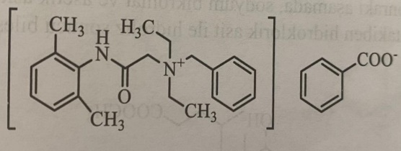
Denatonia benzoate is the most powerful known synthetic digestive agent for the stomach.
Choleretics and cholagogs
Choleretics act on liver cells, increase the secretion of bile and its volume, cholagegs regulate the emptying of the gallbladder. Both groups of preparations are used for some diseases of the biliary tract. This group includes bile acids, derivatives of benzyl alcohol, means that dissolve gallstones, means used in functional disorders of the liver, and other drugs.
Bile acids
Cholic acid and its derivatives belong to this group, they have choleretic action. They induce excretion with bile and secretion of watery bile after absorption from the small intestine. Cholic acid and xenodeoxycholic acid are primary bile acids.
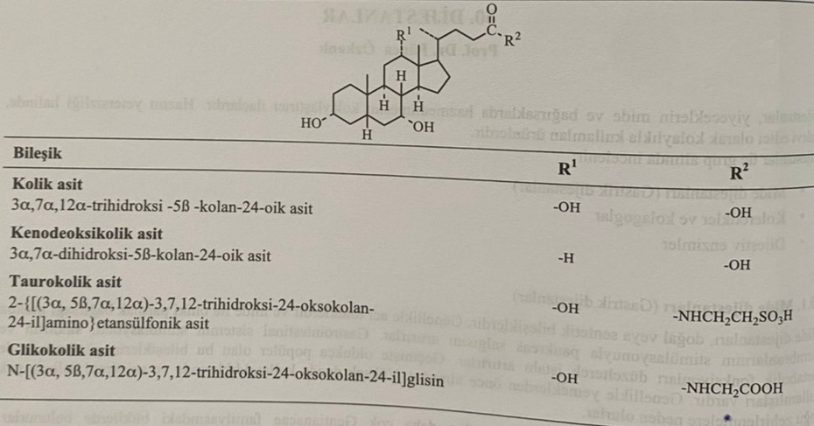
Bile acids are found in bile and intestinal fluid in the form of conjugates with taurine or glycine (taurocholic acid and glycocholic acid). Primary bile acids are synthesized in liver cells and enter the small intestine with bile. Cholic acid is obtained by hydrolysis of human and bull bile. Cholic acid is used in the synthesis of xenodeoxycholic acid. After obtaining the methyl ester of choleic acid, the hydroxyl groups are acetylated with acetic anhydride. At the next stage, a ketone group is formed in the presence of sodium bichromate and acetic acid. After exposure to a mixture of hydrazine hydrate and ethylene glycol, chenodeoxycholic acid is obtained as a result of hydrolysis of HCl.
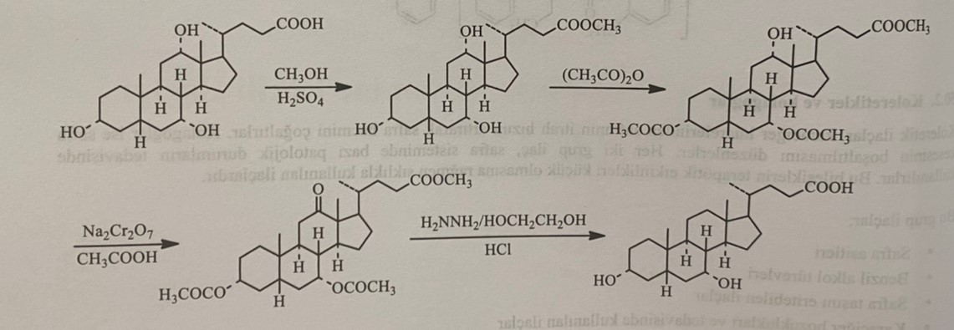
Xenodeoxycholic acid, which belongs to the group of bile acids, is completely absorbed when taken orally. As a result of conjugation with glycine or taurine, N-acyl conjugates (glycochenodeoxycholic acid and tauroxenodeoxycholic acid) are formed in the liver. These conjugated compounds enter the intestinal tract with bile, where they are absorbed by 80%. Unabsorbed amounts of compounds are transformed into new products by bacterial enzymes. As a result of deconjugation, new products of biotransformation are formed, such as free bile acids, 7-oxo derivatives as a result of dehydrogenation, ursodeoxycholic acid as a result of 7β-hydroxyepimerization and litocholic acid as a result of dehydroxylation. Litocholic acid is released from them with feces, and others with bile.
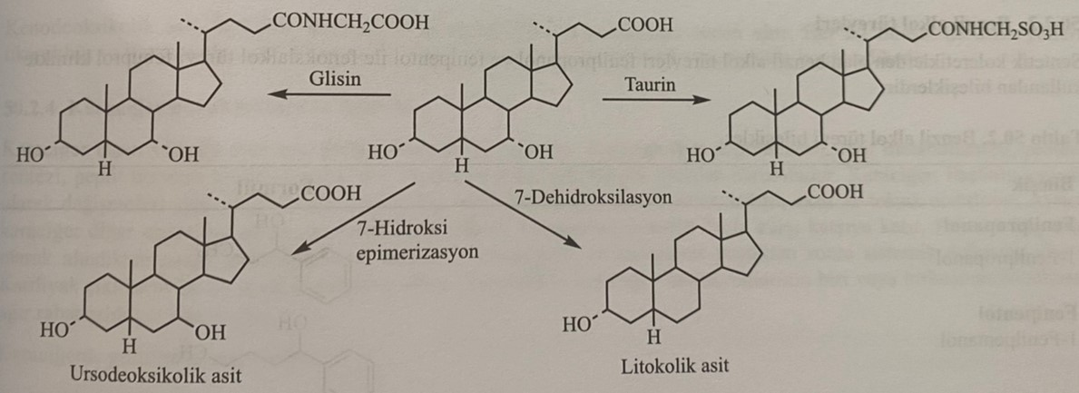
Cholic acid is the main substance in the synthesis of taurocholic acid and glycocholic acid. First, the formyloxy derivative of cholic acid is synthesized with formic acid and a chlorine-containing compound of the carboxyl group with acetyl chloride is formed. Taurocholic acid is formed when the resulting compound reacts with taurine, and glycocholic acid - when it reacts with glycine.
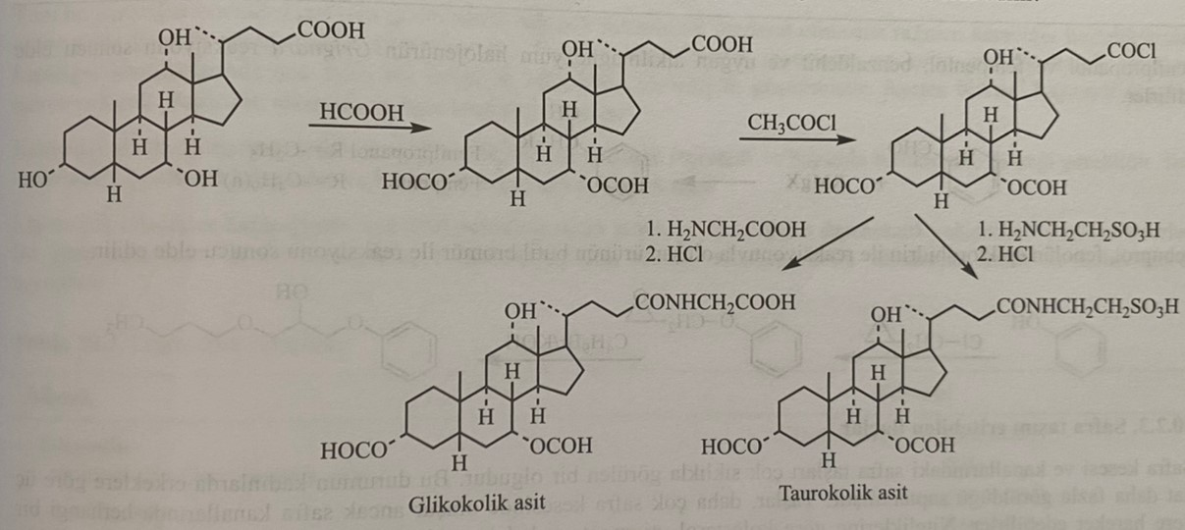
Deoxycholic acid: (3α,5β,12α)-3,12-dihydroxy-5-cholan-24-oic acid
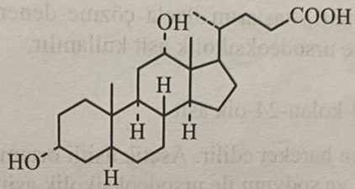
Deoxycholic acid is known as secondary bile acid. It is formed as a result of recovery of cholic acid in the large intestine by intestinal flora bacteria.
Dehydrocholic acid: (5β)-3,7,12-trioxoxalan-24-ovaya acid
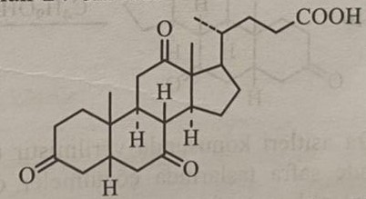
This is the most effective biliary compound. It is formed as a result of dehydrogenation of cholic acid. It is used orally or intravenously in the form of sodium dehydrocholate salt.
Derivatives of benzyl alcohol
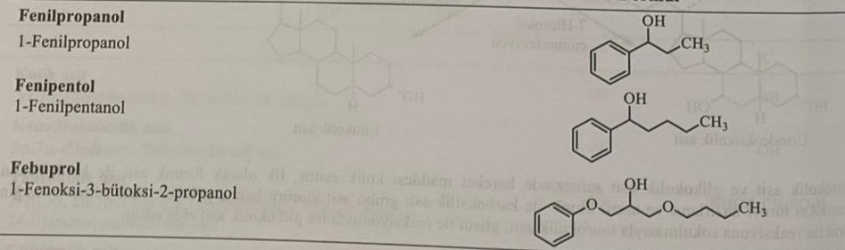
In medical practice, derivatives of benzyl alcohol from the group of synthetic bile acids, phenylpropanol and derivatives of phenoxy alcohol febuprol with phenipentol are used. Phenylpropanol and phenipentol are obtained by the Grignard reaction of benzaldehyde and the corresponding alkynmagnesium halide.
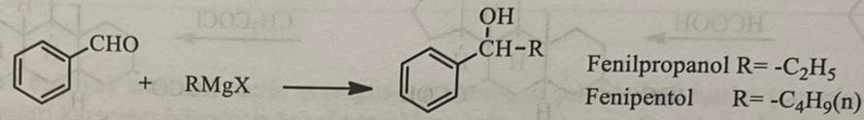
Febuprol is obtained from the reaction of the product formed as a result of the interaction of phenol with epichlorohydrin and butyl bromide.
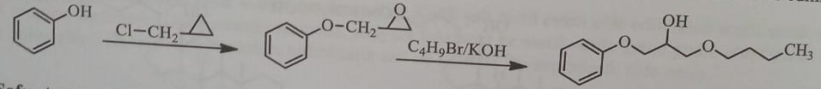
Preparations that dissolve gallstones
The formation of gallstones in the gallbladder and ducts occurs very often. This condition occurs 3 times more often in women than in men. Stones often form in the gallbladder and sometimes move into the duct. According to their classification, gallstones are divided into cholesterol, pigment and carbonate-calcium stones, these stones are more often found in a mixed state. Hypercholesterolemia contributes to the formation of stones in the gallbladder in patients with inflammation and obstruction of the bile ducts. The dissolution of stones in the gall bladder with the help of drugs is promising only for cholesterol stones. Xenodeoxycholic and ursodeoxycholic acids are used for this purpose.
Ursodeoxycholic acid: 3α,7β-dihydroxy-5β-cholan-24-ovaya acid
Chenodeoxycholic acid is used in the synthesis of the compound. In the medium of acetic acid, hydroxyl groups turn into ketones with chromium trioxide. Then, as a result of the interaction of the formed product with butyl alcohol and sodium, ursodeoxycholic acid is formed.
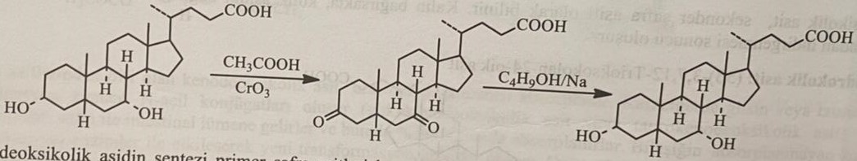
Roughly 60% of patients receiving these drugs experienced gallstone dissolution within 6-24 months. This effect is the result of inhibition of cholesterol biosynthesis and, most likely, cholesterol excretion with bile. The risk of stone recurrence after treatment is 25%. Xenodeoxycholic acid causes gastrointestinal disorders, especially diarrhea. Both combinations are contraindicated in case of obstruction and inflammation of the biliary tract, severe renal and hepatic insufficiency, and also during pregnancy.
Functional disorders of the liver and treatment
The liver is an extremely important organ for the human body. It performs many functions, such as storage of carbohydrates, protein synthesis, inactivation of peptide hormones, production of urea and bile. The liver also plays a very important role in the structural changes of drugs. Active metabolite can be active, inactive and toxic. Unlike other organs, the liver is most susceptible to the effects of drugs. Many medicines are absorbed in the intestine after oral administration, pass through the liver and enter the general bloodstream. 20% of the blood ejected by the heart passes through the liver. Therefore, the violation of one or several functions of the liver leads to the occurrence of secondary diseases.
Liver diseases:
1) Acute liver hepatitis
2) Chronic active hepatitis
3) Fatty liver
4) Liver failure and cirrhosis
Although there are currently many drugs for the treatment of all these liver diseases, the use of these drugs in the treatment of liver diseases is limited. Studies have shown that vitamins, aminomethionine and lipotropic substances, such as choline, do not have a large therapeutic effect in liver diseases. At the same time, the effect of many preparations containing plant raw materials has not been proven yet.
In the treatment of liver diseases, diet and rest, as well as pharmacotherapy, are primarily used. Lipotropic compounds and hepatoprotectors are important in pharmacotherapy.
Lipotropic compounds enhance the breakdown of lipids in the liver and prevent degenerative fatty liver disease. In this group of compounds, methionine, N-acetylmethionine, lecithin, inositol, choline dihydrocitrate, choline chloride are best studied.
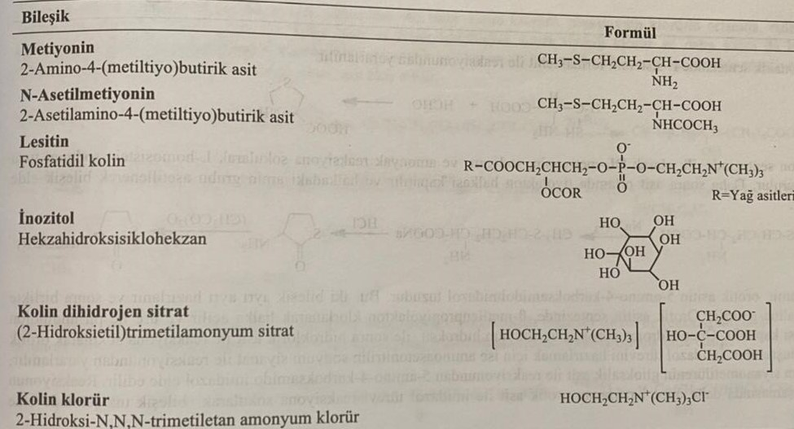
Hepatoprotectors are compounds that regulate liver functions and prevent liver damage. The therapeutic effects of this group of drugs are limited, and the accuracy is still unknown. For these purposes, timonakik, stiolone, orazamit, (+)-cyanidol-3 (catechin), lipoic acid, tiopronin, malotilate are used. Connections are listed in the table.
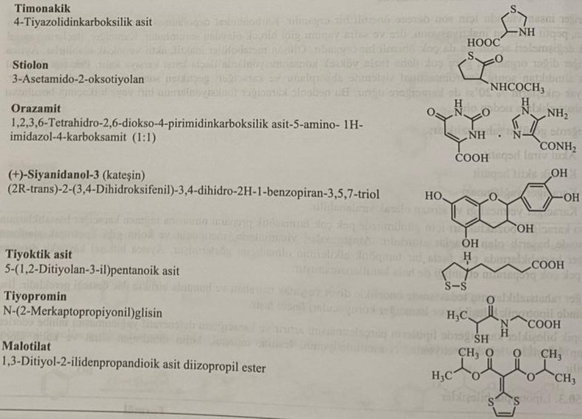
The reaction of L-cysteine with formaldehyde is used in the synthesis of timonakik.
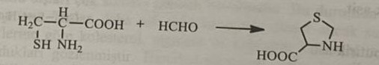
During the synthesis of stiolone, DL-methionine, sodium and ammonia first react with the formation of the sodium salt of L-homocysteine. Then it is cyclized to the thiolactone ring in an acidic medium, and the amino group in the ring is acetylated to form a compound.
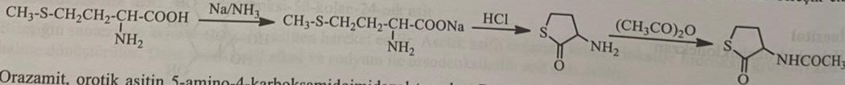
Orsazamide is a 5-amino-4-carboxamidoimidazole salt of oratic acid. These two compounds are obtained separately and salted together. During the synthesis of oratic acid, the β-methylenepropiolactone cycle is opened by chlorination and cyclized into the pyrimidinedione ring by urea. Oratous acid is obtained by reacting first with a mixture of hydrogen peroxide and caustic soda, and then with hydrochloric acid. To obtain imidazole derivatives, he uses the reaction of aminoacetonitrile with sodium cyanate. 5-amino-4-carboxamide imidazole is obtained by the reaction of cyanomethylcarbamide with glyoxal acid. At the last stage of the reaction, the compound is obtained in the form of a salt by the interaction of previously synthesized uric acid with imidazole derivatives.
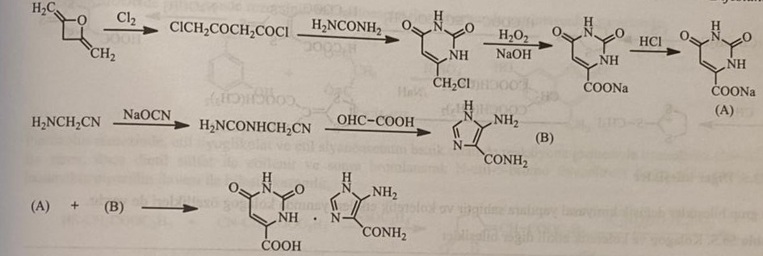
(+)-Cyanidanol is obtained by the reduction of the intermediate product formed as a result of benzoic condensation of 2,4,6-trihydroxyphenylacetaldehyde and 3,4-dihydroxybenzaldehyde, and subsequent cyclization to the benzopyran ring in an acidic medium.
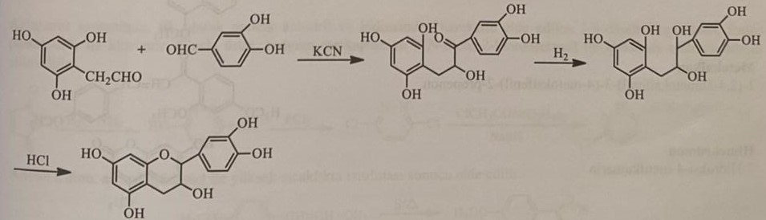
When synthesizing lipoic acid (thioctoic acid) monochloride monoethyl ether of adipic acid is first introduced into the reaction with ethylene in the medium of aluminum chloride. The resulting intermediate product is converted into 6,8-dibenzylthiooctanoic acid by reacting first with sodium borohydride, then with thionyl chloride, and then with benzyl mercaptan. Lipoic acid is formed when the compound interacts with sodium and ammonia followed by iodoform.
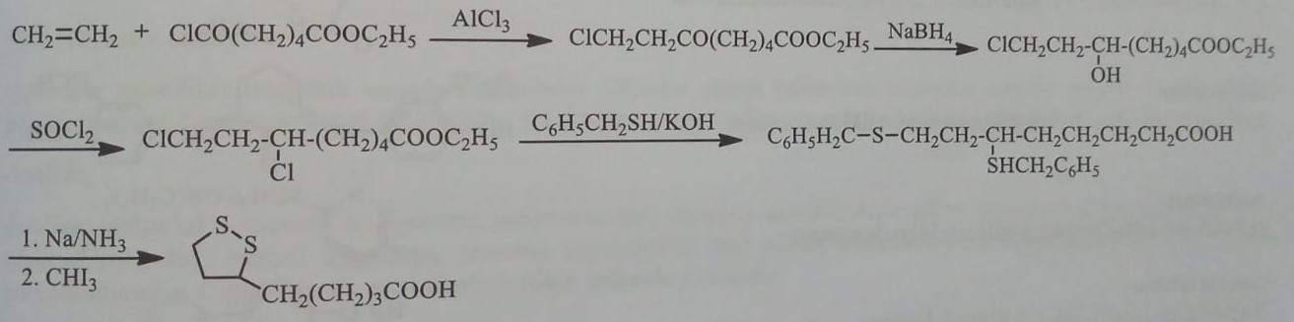
In the synthesis of thiopromine, 2-bromopropionylglycine is synthesized by the reaction of 2-bromopropionyl bromide with glycine in sodium bicarbonate medium. Thiopromine is obtained by the reaction of the processed product with sodium mercaptan.
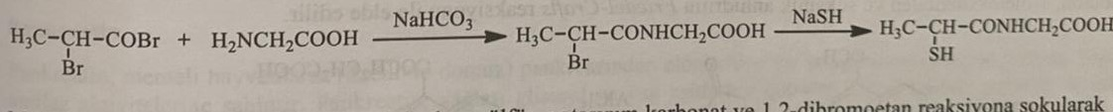
In the production of malotilata, carbon disulfide, potassium carbonate and 1,2-dibromoethane are first reacted and 1,3-dithiol-2-thione is synthesized. When this substance reacts first with dimethylacetylenedicarboxylate, then with sodium methoxide, and then with methyliodide, 2-methylthio-1,3-dithioliiodide is obtained with the subsequent addition of diisopropylmalonate to malotilate.
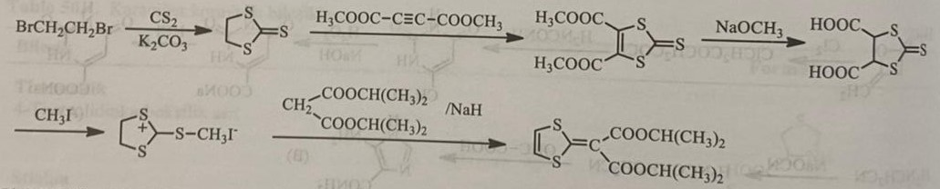
Other connections
This group of compounds has a different chemical structure and, along with the biliary effect, has a biliary effect. These include menbutone, metocalchon, hymecromon, osalmit, piprozolin, cyclovalon, azintamide, anetoltrition.
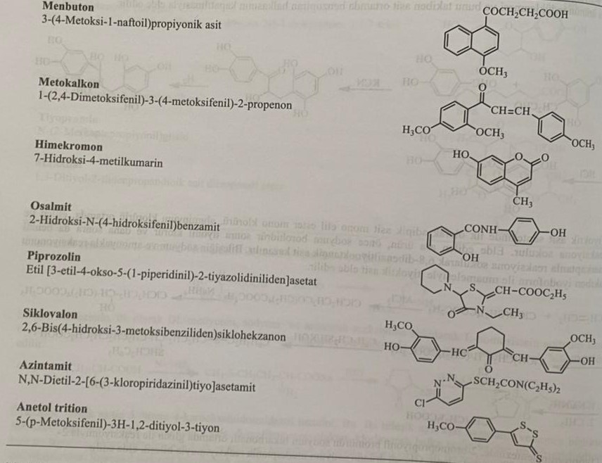
Menbutone is obtained by the Friedel-Crafts reaction of 1-methoxynaphthalene and succinic anhydride.

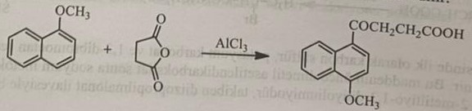
Hemechromone is obtained by heating resorcinol with ethyl acetate in an acidic medium.
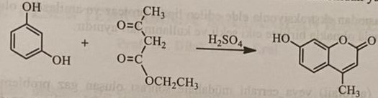
During the synthesis of piprozoline, thiazolinone is obtained by the reaction of ethyl thioglycolate and ethyl cyanoacetate in an alkaline medium. This derivative is first ethylated with diethylsulfate, and then brominated with the formation of derivative N-ethyl-5-bromothiazolinone. At the next stage, the drug is obtained by adding piperidine.
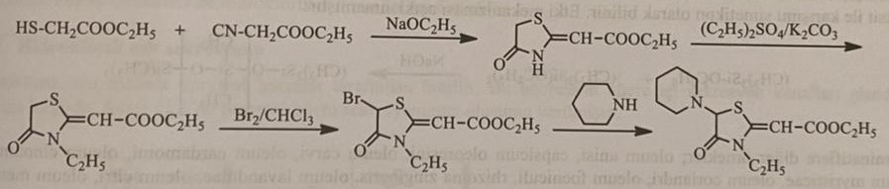
During the synthesis of azinthamide, 3,6-dihydroxypyridazine is chlorinated with phosphorus pentachloride using maleic anhydride and hydrazine. The compound is obtained by condensation of the chlorinated product with sodium mercaptan and N,N-diethyl-2-chloroacetamide.
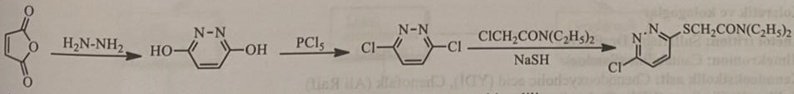
Trithion of anethol is formed when heating anethol with sulfur at a high temperature.
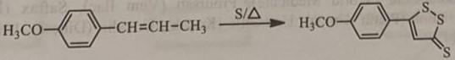
Contraindicated in diseases with obstruction of bile ducts due to liver diseases.
Digestive enzymes
Enzymes are usually used for therapeutic purposes. Digestive enzymes are represented by amylase, cellulase, pancreatin and pancrelipase. They are used separately or in combination in the treatment of enzyme deficiency.
Amylase
Amylase is extracted from the pancreas of mammals, Bacillus subtilis, Aspergillus oryzae and barley. The first application in its production is the artificial digestion of starchy products and the splitting of starch. It is used in combination with other digestive enzymes.
Cellulase
Cellulase is an enzyme that breaks down cellulose, obtained by extraction from Aspergillus niger and other sources. It is used in combination with other enzymes.
Pancreatin
Pancreatin is a mixture of enzymes extracted from the pancreas of mammals. Lipase, protease and amylase possess the activity of a mixture of enzymes. Pancreatin breaks down fats into glycerol and fatty acids, and starch breaks down into dextrin and sugar. It has a restoring effect on proteins. It is used internally in diseases observed in pancreatic insufficiency. In addition to the pharmaceutical sector, pancreatin is also used in the food industry when preparing dairy products.
Pancreatic lipase
Pancrealipase is an enzyme isolated from the pancreas of a pig and its action is similar to pancreatin.
Ventilating means
Ventilating means are used to eliminate foam that is formed after inhalation or surgical intervention. Most of these substances are volatile oils with a weak tanning effect. Demethicone belongs to the group of the most frequently used anti-inflammatory agents and has the chemical structure of dimethylpolysiloxane. The mechanism of action has not been revealed yet.
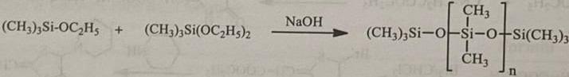
Anti-inflammatory agents include oleum anise, capsicum oleoresin, oleum carvi, oleum cardamoni, oleum cinnamomi, oleum myristicae, oleum coriandri, oleum foeniculi, rhizoma zingiberis, oleum lavandulae, oleum citri, oleum mentha, etc. d.
MEDICINES USED IN THE TREATMENT OF STOMACH ULCER
Gastric juice is an isotonic solution of hydrochloric acid with a pH of 0.5-1.5, which activates the internal factor necessary for the absorption of vitamin B12, digestive enzymes and mucus. On average, the stomach secretes 2-3 liters of gastric juice per day. Hydrochloric acid denatures food proteins, facilitating enzymatic digestion. Hydrochloric acid also activates the corresponding gastric enzymes and turns inactive pepsinogens into active pepsins. Also, bacteria introduced with food are destroyed by hydrochloric acid.
Secretion chloride
Hydrochloric acid is synthesized by parietal cells of the stomach. Transport of H+ and Cl- ions in the membrane of secretory channels is carried out by an active transport mechanism. This transport changes depending on the concentration of Н+, since the intracellular pH value is 7-7.2 and 1 in the secretory channel. The energy necessary for the active transport of protons from the parietal cell to the gastric juice is provided by ATP. This transport is carried out by proton-potassium/ATPase (H+K+/ATPase). H+, which is formed in parietal cells when water and carbon dioxide combine under the action of the enzyme carbonic anhydrase, is thrown into the stomach by active transport, and instead K+ enters the parietal cells. Protons and potassium ions move in the same ratio. This phenomenon is called a proton pump, and the mechanism is based on the generation of ATPase, which depends on hydrogen and potassium ions. Chlorine ions enter the parietal cells from the intestinal fluid, and HCO3- ions are instead released into the intestinal fluid. Chlorine ions are also thrown out of the parietal cell into the stomach cavity by active transport. 150 mmol of H and Cl ions are contained in a liter of gastric juice.
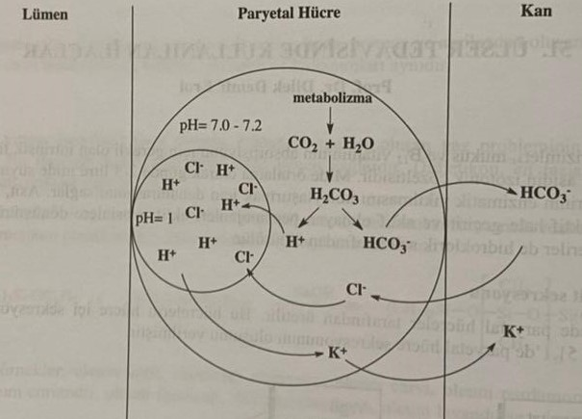
Neurotransmitters, such as acetylcholine, histamine and gastrin, increase the secretion of HCl. These compounds bind to specific cell membrane receptors, acetylcholine binds to muscarinic receptors, H2-histamine receptors, and gastrin binds to gastrin receptors.
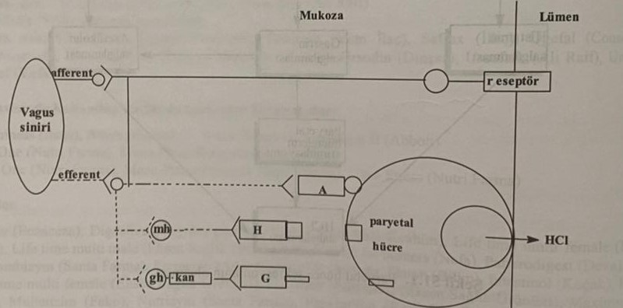
Peptic ulcer
The ulcer is divided into two parts: duodenal ulcer and gastric ulcer. Erosions, called erosions, are visible in the areas in contact with hydrochloric acid and pepsin. Stomach and intestinal ulcers are often called peptic ulcers, but in fact, these two types of ulcers differ from each other in pathogenesis, treatment and clinical features.
Smoking cessation, antacid and antisecretory drugs are usually used to prevent ulcer disease. It is recommended to repeat after stopping the drug. It has been found that Helicobacter pylori is involved in the pathogenesis of gastric ulcer. Long-term healing of these ulcers is achieved due to the eradication of Helicobacter pylori. In the treatment of H. pylori, it is necessary to treat with antibiotics along with inhibition of acidity. The combined use of proton pump inhibitors, macrolide antibiotics, amoxacillin or metronidazole showed a positive effect in the treatment of H. pylori in 90% of patients.
In triple therapy, various combinations are used:
1) Amoxacillin, metronidazole and omeprazole
2) Clarithromycin, metronidazole and omeprazole
3) Amoxacillin, Clarithromycin and Omeprazole
4) Lansoprazole, Clarithromycin and metronidazole
Classification of drugs used in the treatment of peptic ulcers
1) Substances that reduce acid secretion
2) Antacid preparations
3) Those that form a protective layer (Gastroprotectors)
Substances that reduce acid secretion
This group of drugs includes H2-antagonists (cimetidine, ranitidine), cholinergic M1-muscarinic antagonists (pirenzepine) and proton pump inhibitors in the membrane of parietal cells (omeprazole). H2-receptor inhibitors reduce stomach acidity more than sympatholytic drugs.
H2-receptor blockers
This group of drugs is the most frequently used in the treatment of ulcer disease. These drugs block H2-receptors, competing with histamine, that is, these drugs are competitive antagonists of histamine. According to its chemical structure, it is similar to histamine and has a long side chain attached to the imidazole ring chain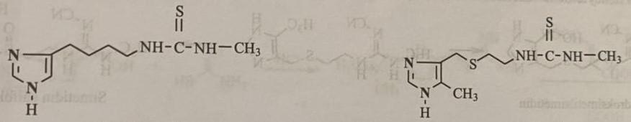
These drugs are currently not used due to side effects. Later, the H₂-receptor blocker cimetidine was synthesized and used for the first time, in which cyanoguanidine is used instead of thiourea, and ranitidine, synthesized after cimetidine, uses a furan ring instead of an imidazole ring. The most important effects of H₂-receptor blockers are in eliminating the action of histamine, which stimulates acid secretion in the stomach, and also in reducing the amount of intrinsic factor secreted by parietal cells. Causes such as insufficient synthesis of this factor for the daily absorption of vitamin B12 and the limited use of H2-receptor blockers in the treatment of vitamin B12 deficiency lead to vitamin B12 deficiency. It does not increase stomach acidity, but blocks normal acid secretion. At the same time, these drugs reduce the secretion of pepsin. The structure-activity relationship of H2-receptor blockers is viewed in three directions.
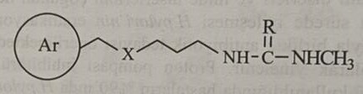
1) Aromatic ring: the imidazole ring in the structure of histamine was chosen as the main structure in the first discovered cimetidine. The activity increases when the methyl group is introduced in the fifth position. Heteroatomic rings, which are isosteres of the imidazole ring, also perform the same function.
2) Intermediate chain: The part represented by X in the intermediate chain can be -CH2-, -O- and -S-. The distance of four carbon atoms between the aromatic structure and the basic structure of the amide is the main factor of activity.
3) Side chain of the main character: this group can be derived from guanyl, thiourea, etc. d. For maximum activation, pKa= should be within 0.4-0.9. Electroacceptor groups such as cyano, nitro, and sulfamoyl form it.
Cimetidine: N-cyano-N,-methyl-N,,-{2[[5-methyl-1H-imidazol-4-yl)methyl]thio]guanidine
Cimetidine is the first H2-receptor blocker offered as a medicinal product. It is well absorbed by the body and rarely passes through the blood-brain barrier.
Cimetidine is obtained by the interaction of 5-methyl-4-aminoethylthiomethylimidazole with thiourea, which is formed by the interaction of 5-methyl-4-hydroxymethylimidazole synthesized from 5-methylimidazole with 2-mercaptoethylamine.
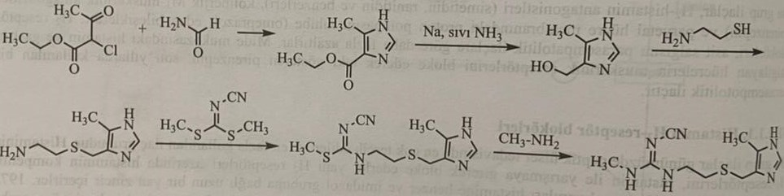
50-80% of the drug is excreted by the kidneys without being metabolized. It has two metabolites.
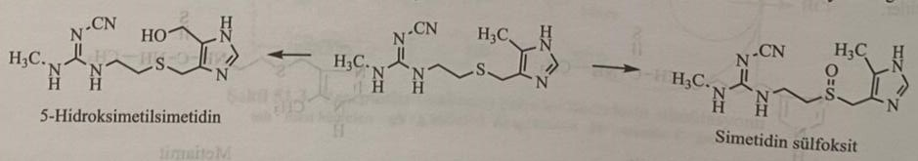
Ranitidine: N-{2-[[5-[(dimethylamino)methyl]2-furanyl]methyl]thio]ethyl}-N,-methyl-2-nitro-1,1-ethanediamine
This is a H2-receptor blocker that activates the aminofuran ring in its structure. The structure of cimetidine and histamine includes furan instead of imidazole. It competitively blocks histamine on H2-receptors. Ranitidine can be synthesized by various methods.
The intermediate product 2-[[5-[(Dimethylamino)methyl]2-furanyl]methyl]thio]ethanamine N-methyl-1-methylthio-2- is obtained as a result of condensation with nitroethenamine at 120°С.
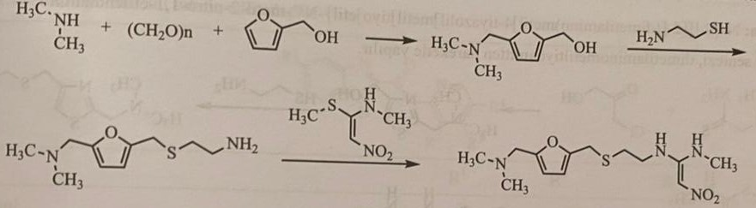
The N-methyl-1-methylthio-2-nitroethenamine used in this method is obtained by the reaction of 1,1-bis(methylthio)-2-nitroethene and methylamine in an ethanol environment.
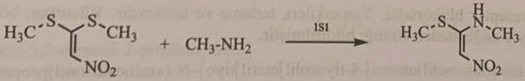
According to another method, ranitidine is obtained by the reaction of 1-ethyleneimino-1-methylamino-2-nitroethene, 5-dimethylaminomethyl-2-mercaptomethylfuran is obtained by the reaction of N-methyl-1-methylthio-2-nitroetheneamine and ethyleneimine. 5-Dimethylaminomethyl-2-mercaptomethylfuran is obtained by bromination of the intermediate product formed during the aminomethylation of 2-hydroxymethylfuran, followed by thiol conversion with hydrogen sulfide.
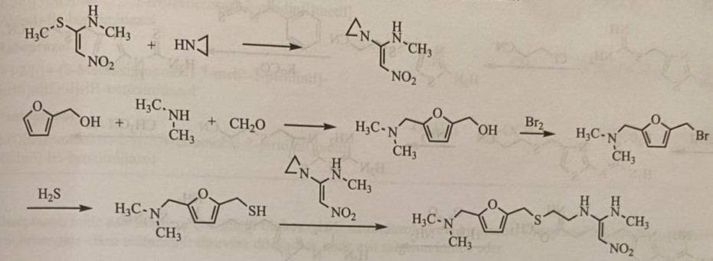
In this method, 5-dimethylaminomethyl-2-furanylmethylisothiourea, formed as a result of the reaction of 5-dimethylaminomethyl-2-furanylmethanol with isothiourea in an acidic medium, is treated with maleic acid to obtain a maleic salt. Mercaptogroup is formed when this product reacts first with sodium metabisulfite, and then with potassium carbonate.
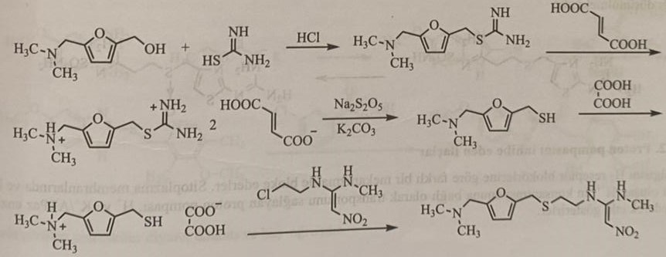
Nizatidine: N- {2- [[2 - (dimethylamino) methyl] 4-thiazolyl] methyl]thio]ethyl} - N, - methyl - 2-nitro - 1,1 - ethylenediamine
Dimethylaminomethylthioamide is used as the starting material for the synthesis of the compound. This is a long-acting H2-receptor blocker. Side effects include sweating and an allergic reaction. It is excreted unchanged from the body through the kidneys.
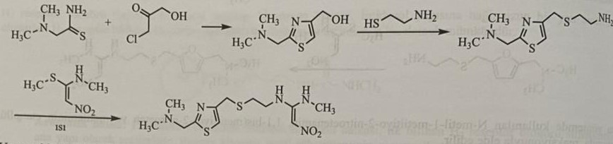
Famotidine: 3-{[[2-[(aminoiminomethyl)amino]-4-thiazolyl]methyl]thio}-N-(aminosulfonyl)propanimidamide
As a result of the reaction of 2-aminothiazol-4-ylmethylisothiourea with 3-chloropropanitrile in an alkaline medium, 2-amino-4-cyanoethylthiomethylthiazole is obtained, the derivative of which is formed as a result of the reaction of this compound first with benzoylisothiocyanate, and then with methyl iodide in potassium carbonate. Famotidine is formed as a result of hydrolysis of urea derivative obtained by reaction with ammonia to nitrile in acidic medium, and then with sulfamide.
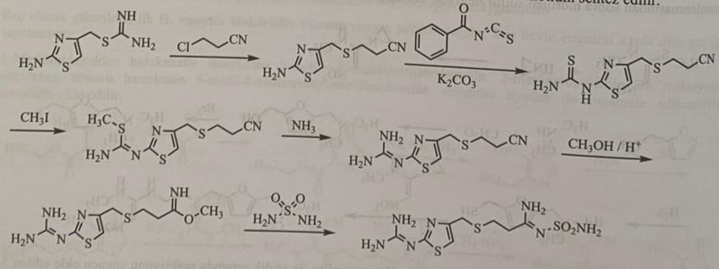
In the structure of famotidine, instead of the imidazole ring of the histamine structure, a derivative of thiazolaminosulfonylpropanimid was synthesized. The effect is long-lasting. Although most of it is excreted unchanged by the kidneys, 5% of the sulfoxide metabolite is found in the urine, and it is considered that this metabolite is inactive.
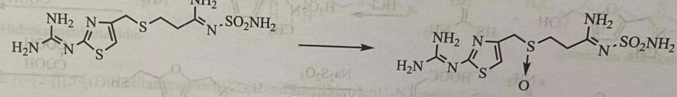
Proton pump inhibitors
They point to another mechanism of preventing acid secretion, which is H2-receptor blockers. They block H+K+/ATPase, a proton pump that transports hydrogen ions depending on the concentration of hydrogen ions in the cytoplasmic membrane and the extracellular environment.
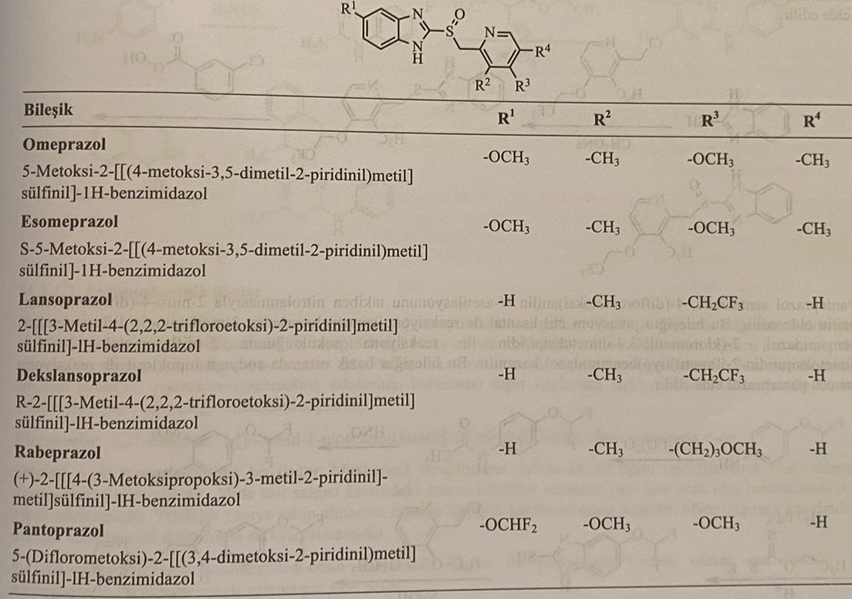
Omeprazole is a derivative of benzimidazole, which very strongly blocks the secretion of gastric juice. Omeprazole is a prodrug that blocks the secretion of gastric juice by turning it into an active sulfonamide derivative in the acidic environment of the stomach.
2-mercapto-5-methoxybenzimidazole is obtained as a result of the reaction of 4-methoxy-o-phenylenediamine with potassium ethylxanthogen, 2-pyridylmethylthiobenzimidazole is obtained as a result of S-alkylation of 2-chloromethyl-3,5-dimethyl-4-methoxypyridine. 2-Pyridylsulfinylbenzimidazole is obtained by oxidation of the thioester group with 3-chloronadbenzoic acid.
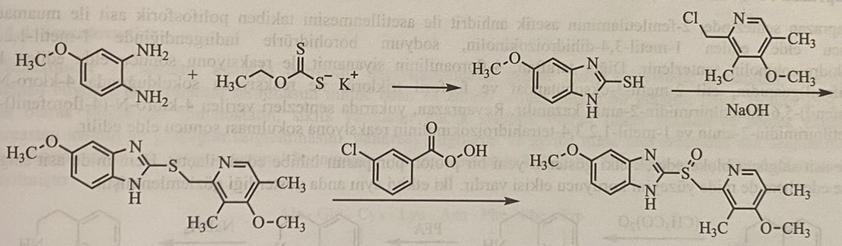
The most common side effects are diarrhea, nausea and headache.
2-[3-methyl-4-(2,2,2-trifluoroethoxy)-2, obtained by the reaction of 2-mercaptobenzimidazole lansoprazole with 2-(chloromethyl)-3-methyl-4-(2,2,2- trifluoroethoxy)pyridine It is formed by the reaction of -pyridylmethylthio]benzimidazole with 3-chlorperbenzoic acid.
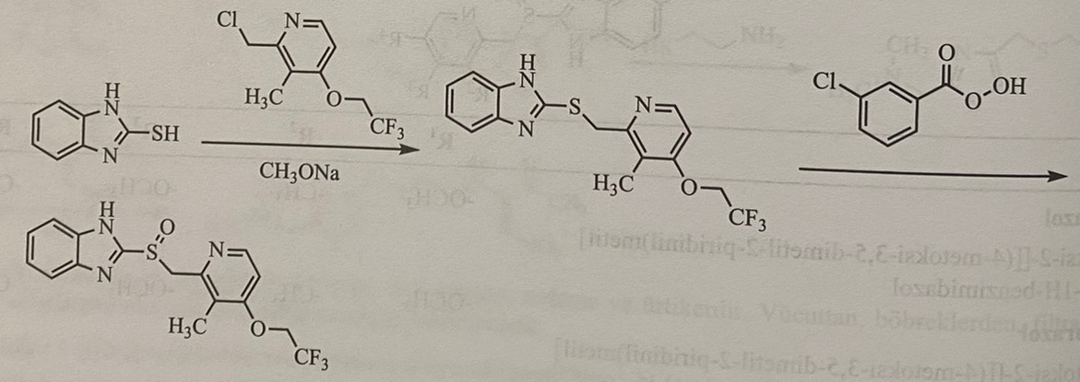
In the synthesis of pantoprazole, 2-nitro-4-(difluoromethoxy)aniline is obtained by N-acetylation of 4-(difluoromethoxy)aniline followed by nitration. 2-mercapto-5-(difluoromethoxy)benzimidazole, which is formed as a result of the reaction of this compound with potassium ethylxanthogen, 5-(difluoromethoxy)-2-(((3,4-dimethoxypyridin-2-yl)methyl)thio) is obtained benzimidazole. As a result of the reaction of this compound with sodium hypochlorite in an alkaline medium, pantaprazole is obtained.
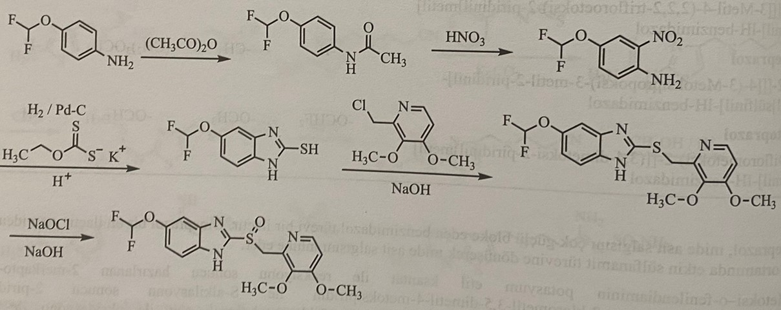
Revaprazan: N-(4-fluorophenyl)-4,5-dimethyl-6-(1-methyl-3,4-dihydro-1H-isoquinolin-2-yl)pyrimidin-2-amine
In the synthesis of Revaprazan, 1-methyl-1,2,3,4-tetrahydroisoquinoline is synthesized by the reduction of 1-methyl-3,4-dihydroisoquinoline, obtained as a result of interaction with polyphosphoric acid after acetylation of 2-phenylethylamine with acetic anhydride, with sodium borohydride. On the other hand, 1-(4-fluorophenyl)guanidine, obtained as a result of the reaction of 4-fluoroaniline with cyanamide, reacts with 2-methyl-3-oxobutanate ethyl ether and phosphoryl trichloride to form 4-chloro-N-(4-fluorophenyl)- 5,6-dimethylpyrimidine is obtained by the reaction of -2-amine and 1-methyl-1,2,3,4-tetrahydroisoquinoline.
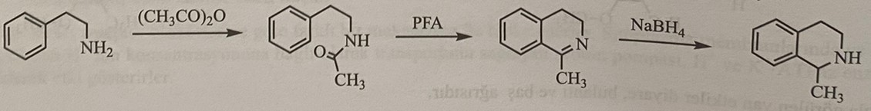
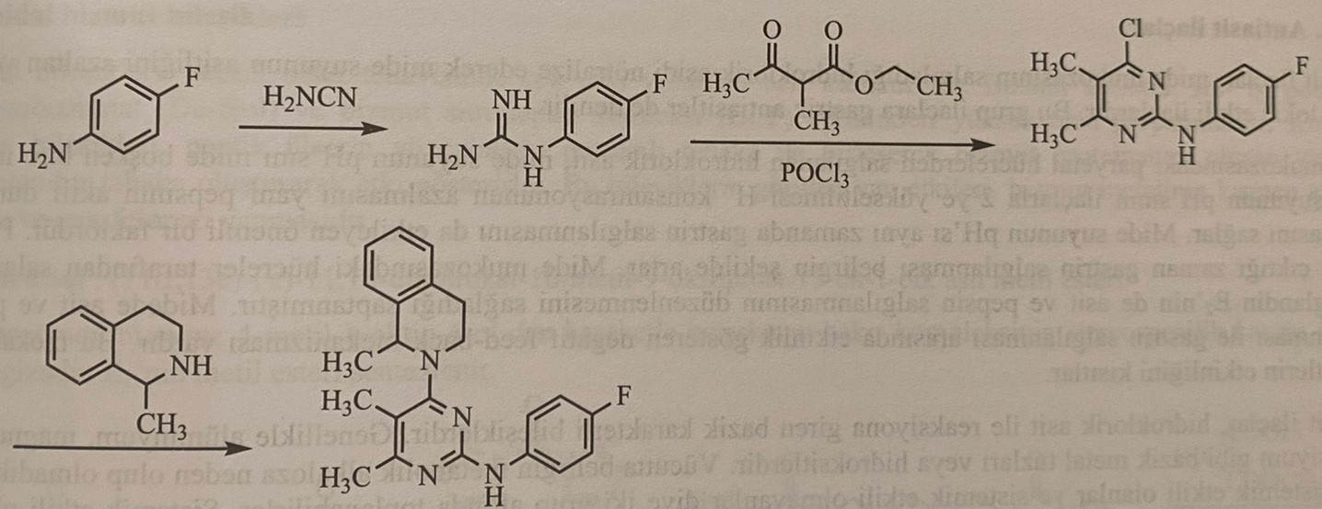
This is a new generation proton pump inhibitor that blocks the secretion of gastric juice. This substance blocks the secretion of gastric juice and protects the inner surface of the stomach (gastroprotector). These two effects were known as a result of studies showing them simultaneously.
Antimuscarinic preparations
These drugs block M1 cell receptors that provide cholinergic stimulation of acid secretion, such as muscarinergic M3 receptors and gastrin receptors located in the parietal cells of the stomach, and reduce the secretion of acid and pepsin due to a decrease in cholinergic tone. They reduce the volume of acid secretion, but do not reduce the concentration of acid. They reduce the time of gastric emptying.
Pirenzepine: 5,11-dihydro-11-[(4-methyl-1-piperazinyl)acetyl]-6H-pyrido[2,3-b][1,4]benzodiazepin-6-one
This is a selective parasympatholytic drug that has a gastroselective effect due to the blocking of only the M1-subtype of muscarinic receptors, in addition to the inhibitory effect on the secretion of gastric juice, it also has a parasympatholytic effect. Although it has a tricyclic structure, it does not have lipophilic properties. Due to partial absorption from the gastrointestinal tract, the duration of action is longer.
It is obtained by the reaction of 5,11-dihydro-6H-pyridobenzodiazepin-6-one with chloroacetyl chloride, an intermediate compound with 1-methylpiperazine.
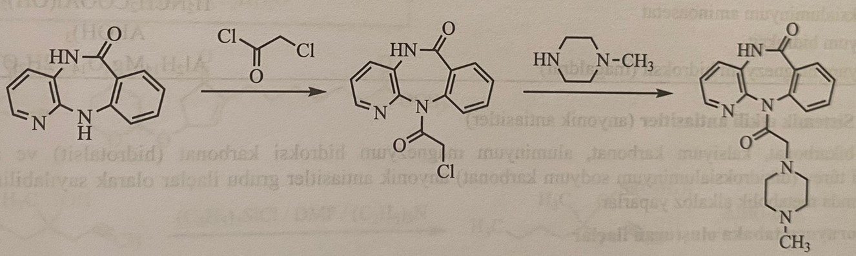
Somatostatin
Somatostatin-14 and its synthetic analogue octreotite are a peptide of 14 amino acids, which inhibits the secretion of growth hormone secreted by the pituitary gland, and is used in the treatment of peptic ulcers. Naturally secreted somatostatin has a cyclic structure, but it can also be synthesized synthetically in linear form. It reduces the secretion of insulin and glucagon by the pancreas, other secretions of the pancreas and the secretion of gastric juice. Somatostatin-14 is used to stop gastrointestinal bleeding. The amino acid sequence of the compound is shown below.
The action of somatostatin-14 is not selective and it is administered only intravenously, since it is very quickly metabolized in the plasma.
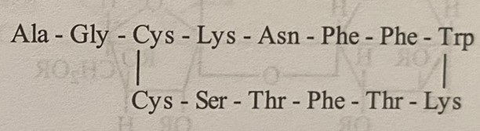
Antacid preparations
Antacids work by neutralizing hydrochloric acid, which is secreted in the stomach. Hydrochloric acid, produced by the parietal cells of the stomach, reduces the pH of the stomach to 1 when the stomach is empty. Increasing the pH of the stomach to 2 with drugs causes a decrease in the concentration of hydrogen ions in the stomach, and pepsin remains active. pH-I of gastric juice is also an important factor for the synthesis of gastrin. At pH higher than 4.4, the synthesis of gastrin in the stomach increases. Prostaglandin E2, synthesized by the cells of the stomach, plays a key role in the regulation of acidity and pepsin. There is a negative direct relationship between the secretion of acid pepsin and the secretion of gastrin in the stomach. There is a reverse mechanism. This mechanism limits the use of antacids.
Antacids are the main compounds that can react with hydrochloric acid. Usually, aluminum, magnesium and calcium salts and hydroxides are used as antacids. Depending on whether they cause metabolic alkalosis in the body, they are divided into systemic and non-systemic antacids. Systemic ones cause neutralization on the anion side, and non-systemic ones cause neutralization on the cationic side.
Antacids without systemic action
These are compounds of aluminum, magnesium and calcium, which after neutralization of acid in the stomach turn into water-soluble chloride salts. A very small part of the metal ion is absorbed, and the rest forms a precipitate with bicarbonates in the intestine. Deposition of carbonates in the intestines prevents metabolic alkalosis, preventing the absorption of metals into the blood.
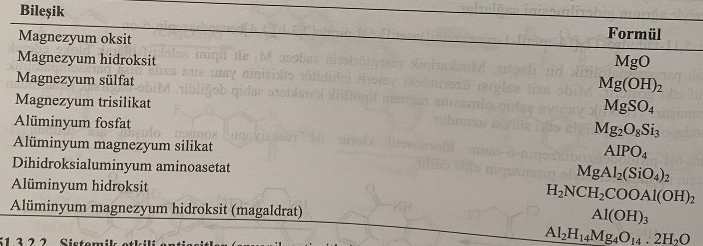
Antacids of systemic action
Sodium bicarbonate, calcium carbonate, aluminum-magnesium hydroxycarbonate and aluminum hydroxide derivative (sodium dihydroxyaluminum carbonate) are included in the group of anionic antacids. When ingested, they cause metabolic alkalosis.
Preparations that form a protective layer (Gastroprotectors)
Sucralfate: D-fructofuranosyl-α-D-glucopyranoside octakis (hydrogen sulfate) aluminum complex
Sucrose is a complex of octasulfate aluminum hydroxide. Forming a complex with a protein-fibrinogen layer on the injured area, it forms a sticky layer, absorbs pepsin and bile acids, reduces the effect of pepsin. It does not reduce the secretion of hydrochloric acid and does not neutralize it. 12-finger is used for intestinal ulcers.
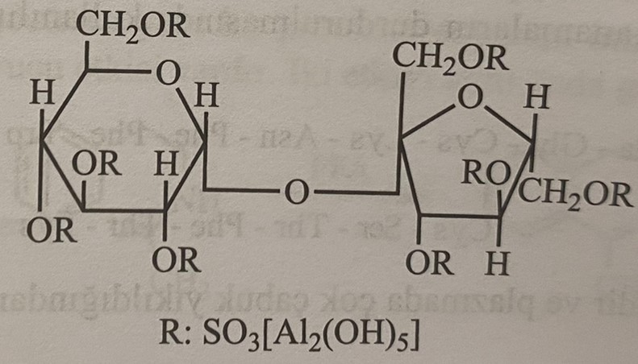
Colloidal compounds of bismuth
Bismuth compounds have been used for many years in the treatment of peptic ulcer disease. Highly effective preparations are subcitrate bismuth sol-tri disitratobismuthate potassium (De-nol) and bismuth citropeptide complex (BCP). which this layer is sticky and covers the ulcer. Side effects of these compounds are bismuth absorption and encephalopathy.
Misoprostol: methyl ester (11α,13e)-(+-)-11,16-dihydroxy-16-methyl-9-oxoprost-13-en-1-oitacid. The methyl ester of prostoglandin E₁ is synthesized as a result of the stereospecific inclusion of a copper complex in the cyclopentenone derivative using 4-methyl-1-octyn-4-ol.
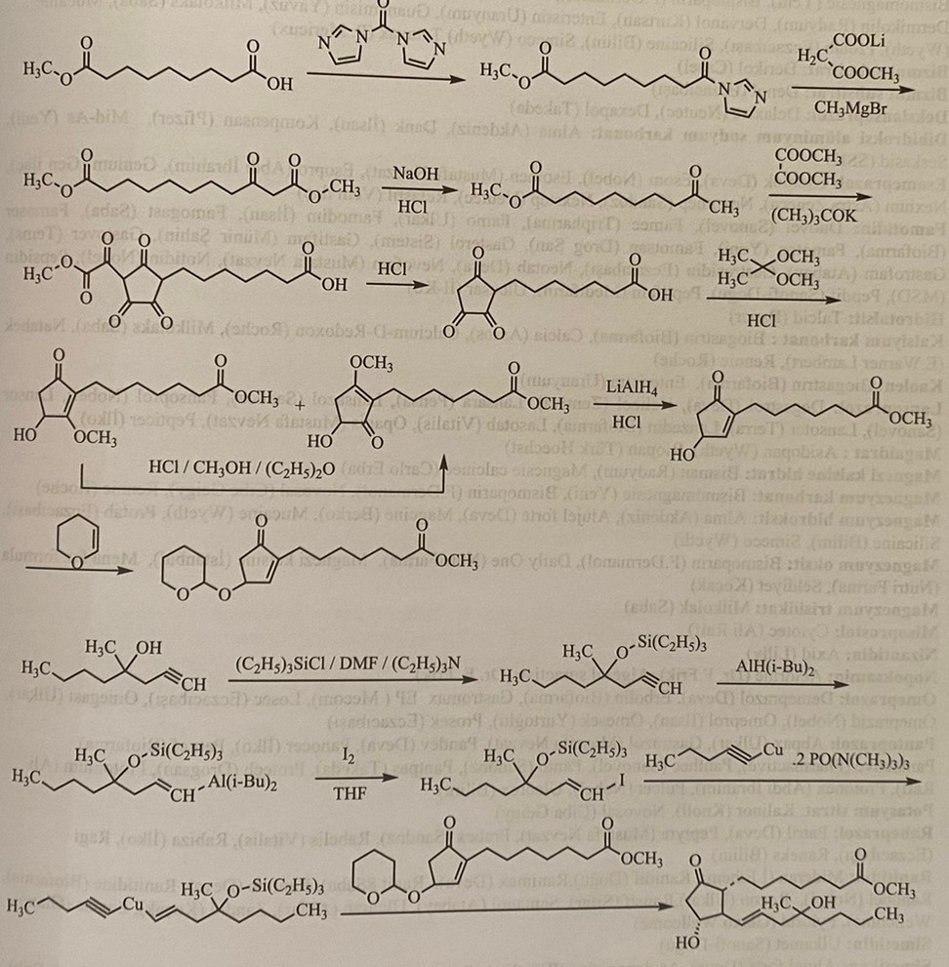
Prostoglandin E increases the secretion of bicarbonates by the gastric juice, inhibits the secretion of gastric juice by the glands and reduces the secretion of hydrochloric acid. Misoprostol is a derivative of prostaglandin E and is the only drug used for the treatment of stomach ulcers, and has the structure of a complex ester. The ether structure is metabolized in the body and becomes an acid structure, and the drug has an effect. Thus, this drug is a prodrug.
Vomiting (vomiting) and antiemetic (antivomiting) preparations
Emetics are drugs that cause vomiting. They are especially used in the treatment of poisoning. They directly interact with the chemoreceptors of the vomiting center of the central nervous system. The effect increases when taken with a large amount of water. Contraindicated in cases of fainting, intoxication, semi-comatose states, poisoning with gasoline products and volatile compounds. Vomiting drugs are studied in two groups.
1) Peripherally effective
2) Centrally effective
Emetic agents with peripheral action include copper sulfate, zinc sulfate, potassium tartaric antimony. One of the most frequently used emetics is syrup of ipecac. However, ipecacuan syrup should not be confused with ipecacuan extract. Ipecacuanha extract is 14 times stronger than ipecacuanha syrup and can cause death.
Apomorphine hydrochloride is the most frequently used emetic agent of central action.
Apomorphine hydrochloride: hemihydrate (R)-5,6,6a-7-tetrahydro-6-methyl-4H-dibenzo[de,g]quinoline-10,11-diol hydrochloride.
Apomorphine is obtained by heating morphine under pressure at 140°C with a 35% solution of hydrochloric acid.
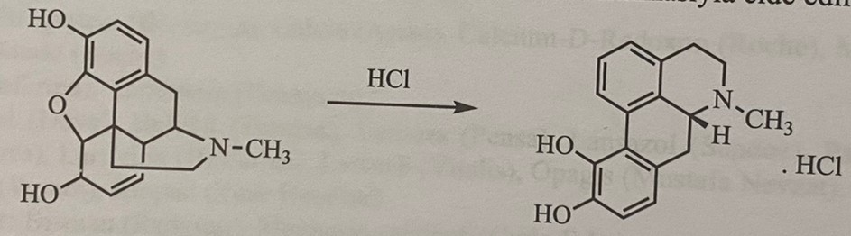
Apomorphin acts directly on chemoreceptors located in the trigger zone, and has an emetic effect during several minutes. Ophoria causes tremors and rapid movement. In this case, naloxone is used as an antidote. It is ineffective orally, it is applied subcutaneously.
antiemetics
Antiemetics – substances that stop vomiting. They prevent vomiting by acting on chemoreceptors in the central nervous system. Vomiting is a general symptom, not a specific condition. Vomiting is observed in diseases of the stomach, biliary tract, inflammation of the pancreas, intracranial pressure, uremia, hepatic coma, brain tumors and some infectious diseases. In some periods of pregnancy, vomiting can be observed even after medication and X-ray examination. Single vomiting did not cause significant problems and was physiological in nature. An increase in the amount of vomiting has a pathological character and causes loss of water and electrolytes. As a result, hypochloremic alkalosis, oliguria, dry mouth, fever and coma occur.
Antiemetics are divided into 6 groups.
1) Tropan alkaloids
2) Antagonists of histamine H1-receptors
3) phenothiazine
4) Derivatives of benzamide and benzimidazolone
5) Antagonists of serotonin (5-hydroxytryptamine)
6) Vitamin B6
Tropanovy alkaloids
Scopolamine and hyoscyamine, which are tropane alkaloids, are used instead of some synthetic drugs, including antihistamines and neuroleptics. Scopolamine, acting on impulses originating from the inner ear, has a strong antiemetic effect.
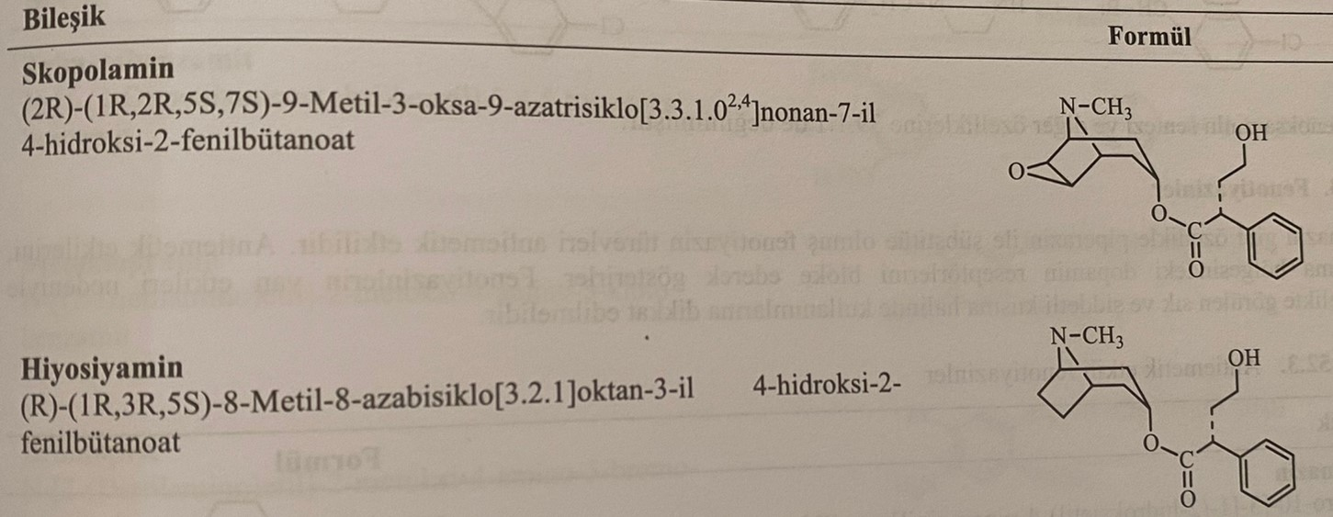
Antagonists of H1-receptors
Antagonists of H1-receptors, dimenhydrinate, meclizine and chlorphenoxamine, representing the 8-chlorotheophylline salt of diphenhydramine, are drugs used as antiemetic agents. It is believed that the action of these compounds is realized in the inner ear. Benzhydryl derivatives are used for the prevention and treatment of motion sickness. They are accepted for an hour and a half before the trip. The medication is repeated every 4 hours. Since the teratogenic effects of these compounds have not been fully studied, it is recommended to be cautious after the 16th week of pregnancy. Benzhydryl bromide is used in the synthesis of dimenhydrinate.
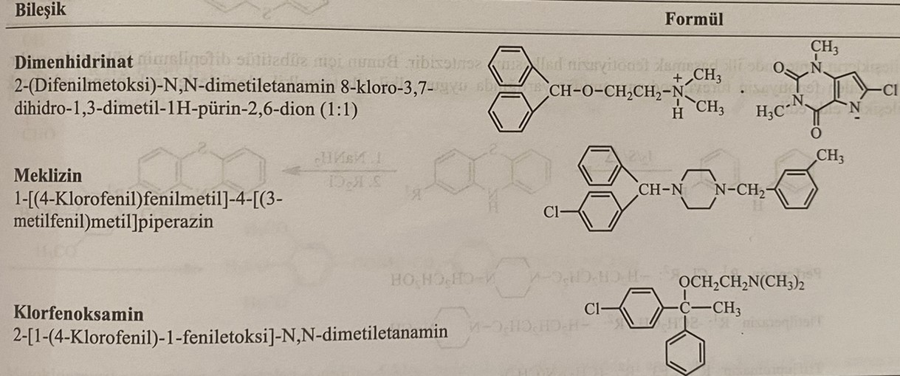
The drug is obtained by reacting the product formed as a result of the reaction of benzhydril bromide with 2-dimethylaminoethanol and 8-chlorotheophylline in a ratio of 1:1.
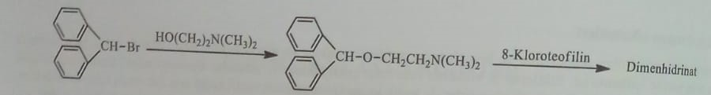
Meclizine is obtained from the reaction of 4-chlorobenzhydryl bromide and 3-methylbenzinepiperazine.
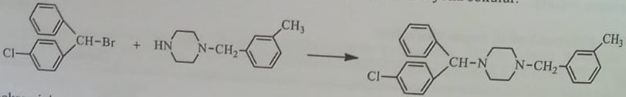
Phenothiazine
Derivatives of phenothiazine, especially piperazine, for example perphenazine, have an antiemetic effect. They exert their antiemetic action by blocking dopamine receptors located in the postrenal region. The use of phenothiazines during pregnancy is limited due to multiple side effects. The first stage of the synthesis of antiemetics based on phenothiazine is the synthesis of the phenothiazine ring. For this, diphenylamine is heated with sulfur. At the second stage, the phenothiazine ring interacts with a suitable alkyl chloride in the presence of sodium amine and the compound is synthesized.
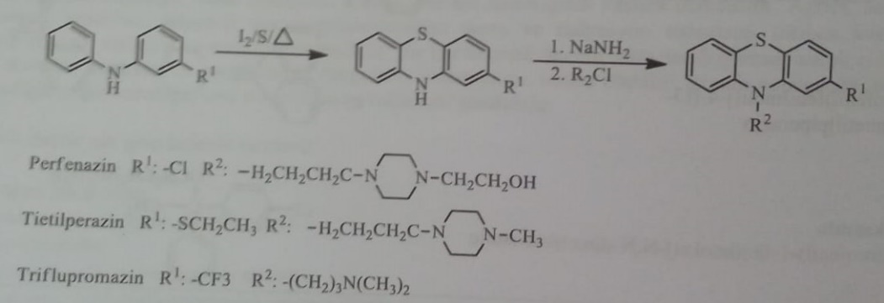
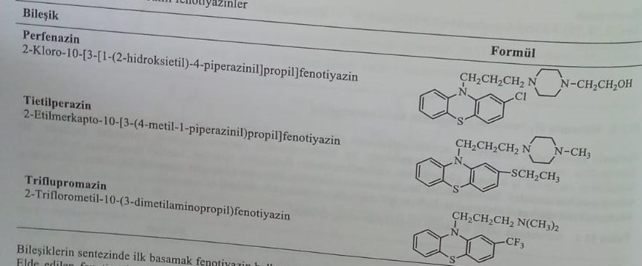
Derivatives of benzamide and benzimidazole
Derivatives of benzamide and 2-benzimidazole are antiemetics, similar to derivatives of phenothiazine, and block dopamine receptors located in the postrenal region. In addition, unlike phenothiazines, they do not have neuroleptic and tranquilizing properties. This group of antiemetics is less effective when sedated. Trimetabenzamide, metoclopramide, bromoprid, domperidone belong to this group.
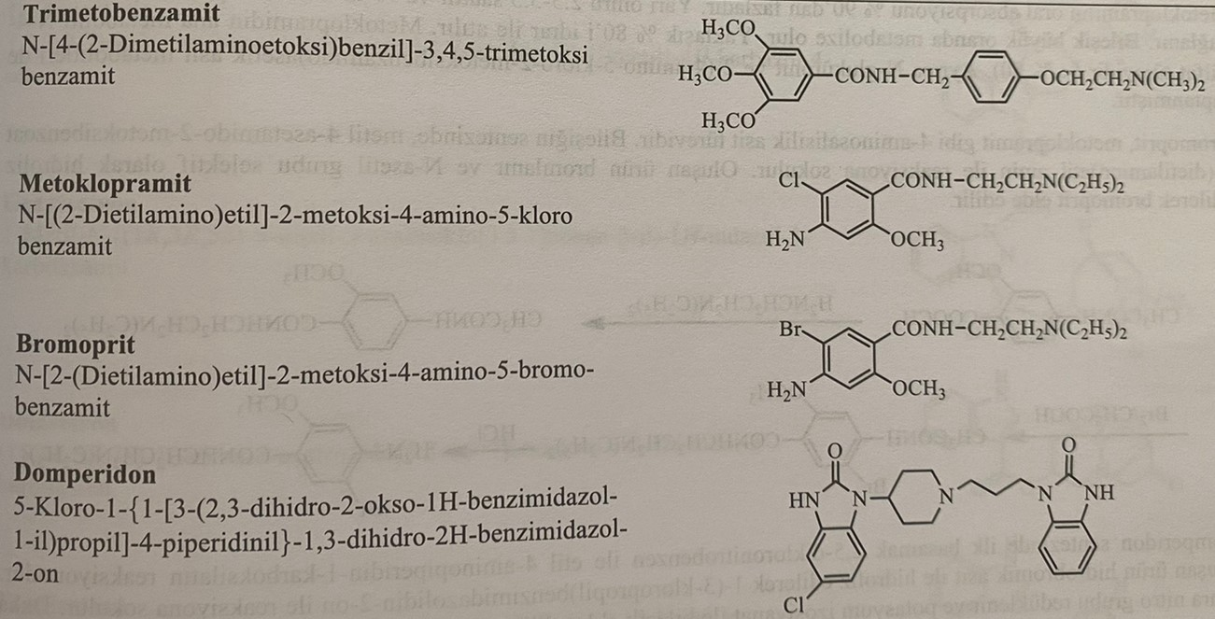
When synthesizing trimethobenzamide, 4-(2-dimethylaminoethoxy)benzaldehyde, formed as a result of the reaction of 4-hydroxybenzaldehyde and 2-chloroethyl-N,N-dimethylamine, is added to the reaction with ammonia/H2/Raney nickel and a derivative of benzaldehyde. turns into a benzylamine structure. At the last stage, the compound is obtained by reacting the substance with 3,4,5-trimethoxybenzoyl chloride.
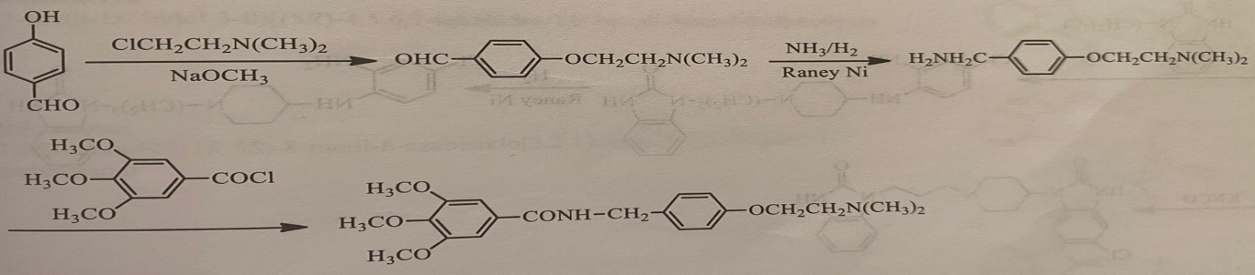
In the synthesis of metoclopramide, the amino group in the molecule of 2-methoxy-4-amino-5-chlorobenzoic acid is acetylated. Then, the acid group is converted into acid chloride with thionyl chloride, and the compound is synthesized by reacting with 2-(diethylamino)ethyl amine.
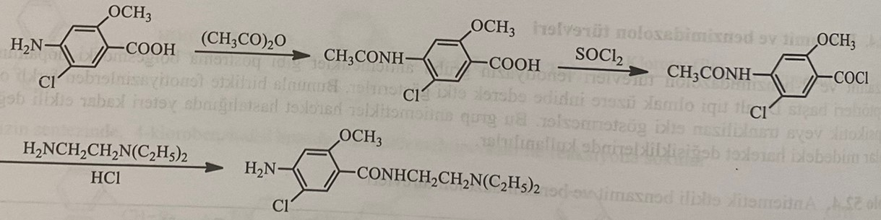
Absorption of metoclopramide when taken orally exceeds 90%. The half-life is 2.5-5.5 hours, 40% binds to plasma proteins. About 80% is excreted in the urine. The main metabolite of metoclopramide is a derivative of N-4-sulfate. At the same time, metabolites of N-glucuronide and 2-(4-amino-5-chloro-2-methoxybenzamido)acetic acid were detected.
Bromoprid is a derivative of 4-aminosalicylic acid, like metoclopramide. When synthesizing the compound, methyl-4-acetamido-2-methoxybenzoate interacts with 2-(diethylamino)ethylamine. The resulting product is brominated and selectively hydrolyzed with the N-acetyl group to obtain bromide.
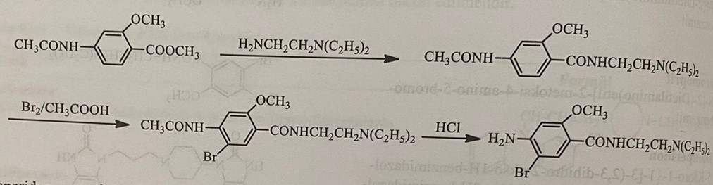
The first step in the synthesis of domperidone is the reaction of 4-aminopiperidine-1-carboxylate with 2,5-dichloronitrobenzene. The obtained product is hydrolyzed with hydrobromic acid and introduced into the reaction with 1-(3-chloropropyl)benzimidazolidin-2-one. Then they restore the nitro group and then get the preparation by reacting with potassium isocyanate.
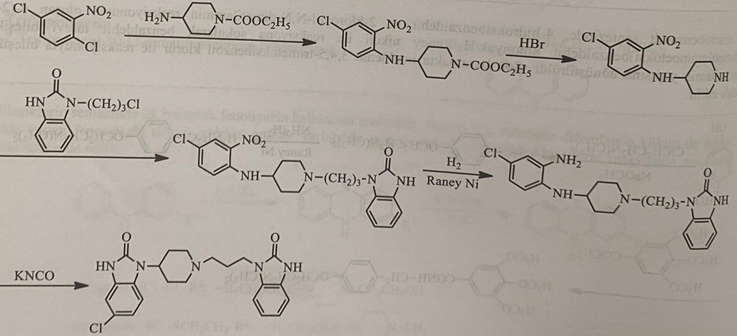
Oral absorption of domperidone is 93%. The half-life is 7.5 hours and its binding to plasma proteins is 91-93%. Conjugation and elimination are preceded by aromatic hydroxylation and oxidative dealkylation reactions in metabolism. Hydroxy domperidone, 3-(2-oxo-2,3-dihydro-1H-benzene[d]imidazol-1-yl)propionic acid and 5-chloro-1-(piperidin-4-yl)-1H formed as a result of biotransformation -benzene[d]-imidazol-2(3H)-one products.
Serotonin antagonists
Serotonin or 5-hydroxytryptamine antagonists are very useful and convenient combinations in cytostatic therapy or radiation-induced emesis. The first manufactured drug of this group is ondansetron.
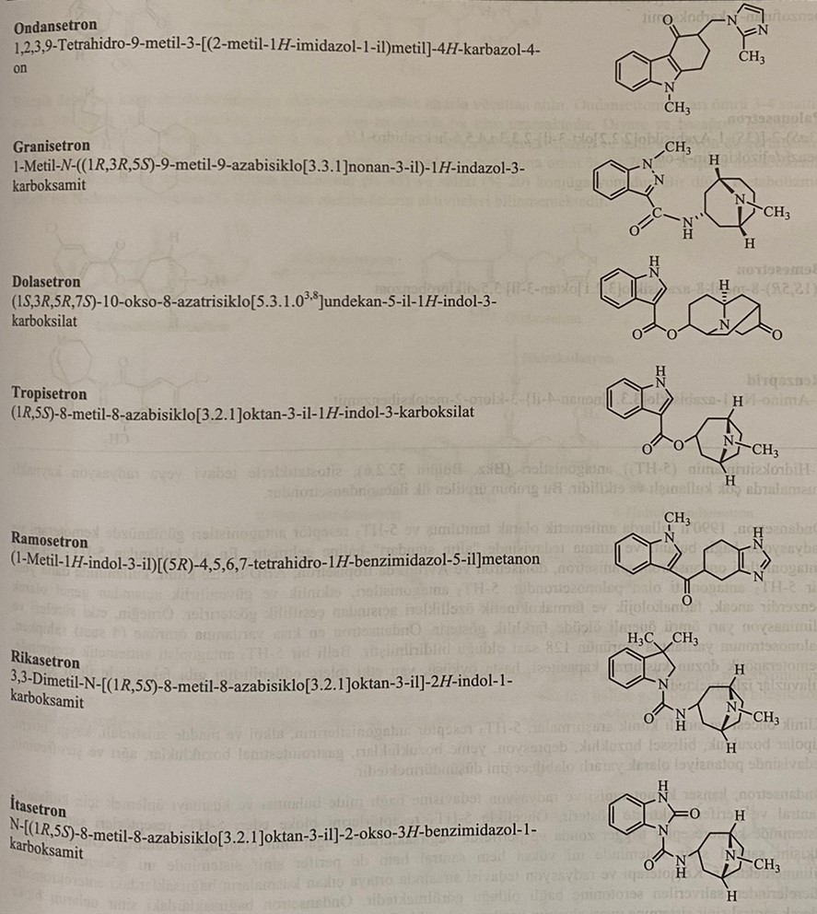
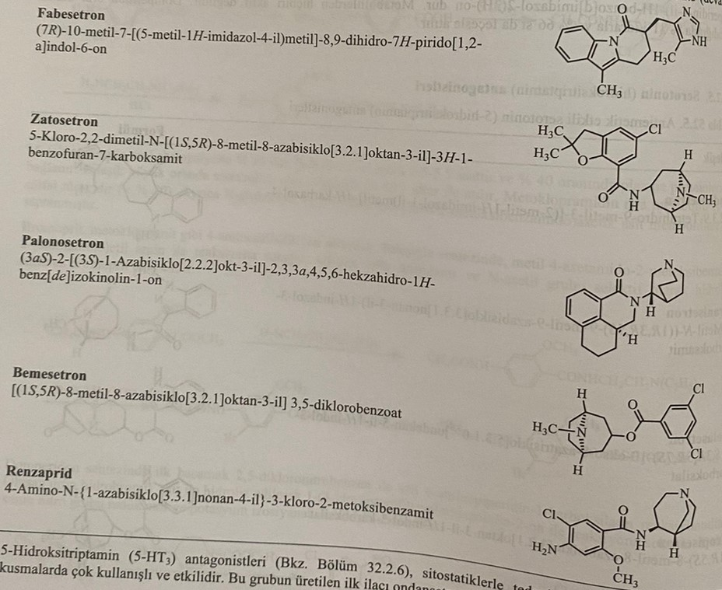 Ondansetron was developed in the 1990s as an antiemetic, and 5-HT3 receptor antagonists have become the "gold standard" in the treatment of nausea and vomiting caused by chemotherapy and radiation. The most commonly used antagonists of 5HT3 receptors are ondansetron, granisetron, dolasetron and tropisetron in Europe, as well as palonosetron, which recently began clinical use in the USA. and the half-breeding period. Ondansetron has the shortest half-life (4 hours), and palonosetron has a half-life of 128 hours. When choosing one or another antiemetic agent, it is necessary to control the vomiting force of chemotherapy drugs, the general condition of the patient and other factors.
Clinical studies show that 5HT3 antagonists can be useful in the treatment of alcoholism and drug addiction, care for patients, bipolar disorders, depression, gastrointestinal disorders, pain and schizophrenia.
Ondansetron is used to prevent nausea and vomiting caused by cancer chemotherapy and radiation therapy. It shows central and peripheral activity. First, it blocks 5HT3 receptors. 5HT3 receptors are located in the trigger zone of chemoreceptors in the central nervous system and peripherally in afferent nerve endings in the intestines. Whether the effect of ondansetron is exclusively central or both central and peripheral is a subject of controversy. It is known that vomiting during chemotherapy and radiation therapy is caused by serotonin released from enterochromaffin cells in the intestines. Ondansetron acts by blocking the nerve endings in the intestine, preventing the conduction of nerve impulses from the periphery to the center.
When synthesizing ondansetron, phenylhydrazine is used as a starting material. For this, the first phenylhydrazine is subjected to interaction with 1,3-cyclohexadione, resulting in the formation of a hydrazone. Tetrahydrocarbazolone is obtained by reacting hydrazone with zinc chloride in sulfuric acid medium. After alkylation with methyliodate, this compound reacts with formaldehyde and methylimidazole to form ondansetron.
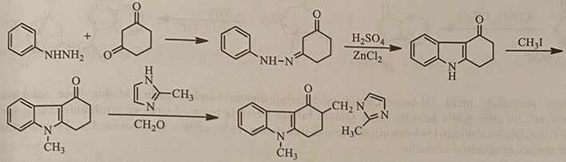
Ondansetron is metabolized in the liver and the metabolites are excreted in the urine. The half-life of ondansetron is 3-4 hours, but this period is prolonged in the elderly and in patients with liver failure. The most known side effects are diarrhea and headache. At the same time, constipation, skin redness, dizziness, bronchospasm and slight sedation can be seen. Oral absorption of ondansetron is 59%, and the probability of binding to plasma proteins is 70-75%. The major metabolic reactions are hydroxylation followed by glucuronide (45%) and sulfate (20%) conjugation. Another metabolic reaction is N-demethylation (10%). The activity of the active metabolites has not been studied.
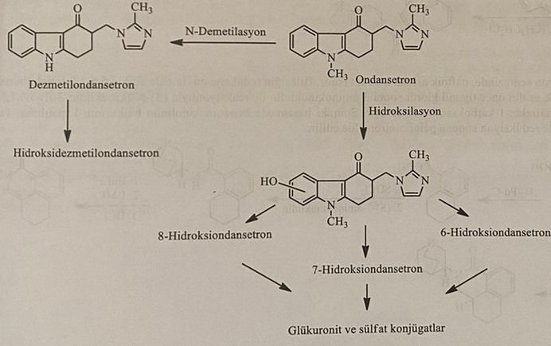
The first step in granisetron synthesis is the N-alkylation reaction of 1H-indazole-3-carboxylic acid with methyl iodide. As a result of the reaction of the processed product with oxalyl chloride, the carboxylic acid group turns into an acid chloride group. The resulting compound reacts with 9-methyl-9-azabicyclo[3.3.1]nonan-3-amine in the final step to give granisetron.
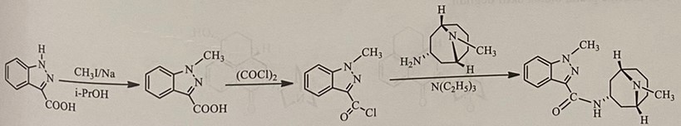
The initial substance in the synthesis of tropisetron is 1H-indole-3-carboxylic acid. Tropisetron is obtained from the reaction of 1H-indole-3-carbonyl chloride with 8-methyl-8-azabicyclo[3.2.1]octan-3-ol, obtained by the reaction of the compound with oxalyl chloride.
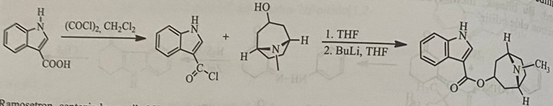
In the synthesis of ramosetron, methyl 1H-benzo[d]imidazole-5-carboxylate is used. The substance is first reduced, then the ester group is hydrolyzed with hydrochloric acid. The resulting compound is sequentially reacted with thionyl chloride and pyrrolidine to give pyrrolidin-1-yl(4,5,6,7-tetrahydro-1H-benzo[d]imidazol-5-yl)methanone. In the last step, ramosetron is obtained as a result of reaction with 1-methyl-1H-indole.
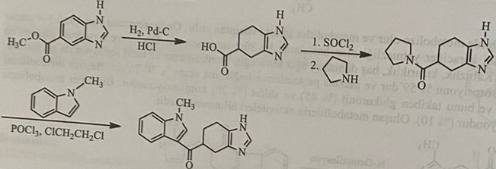
In the synthesis of palonosetron, naphthoic acid is used as a starting material. (S)-N-(quinuclidin-3-yl)-5,6,7,8 from the reaction of 5,6,7,8-tetrahydronaphthalene-1-carboxylic acid with first thionyl chloride and then with 3-aminoquinuclidine, obtained by the reduction of the compound -5,6,7,8-tetrahydronaphthalene-1-carboxamide is synthesized. In the next step, palonosetron is obtained as a result of closing the benzoisoquinolinone ring followed by reduction with H2/Pd-C.
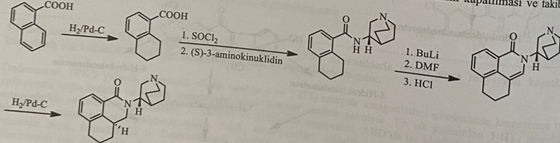
After oral administration, palonosetron is well absorbed from the intestines and has an absorption rate of 97%. Peak plasma levels are seen within 1.5-5 hours regardless of food. The probability of binding to plasma proteins is 62%. 40% of the substance is excreted unchanged. Two main metabolites N-oxide and hydroxy derivative have 1% antagonistic effect. For this reason, it is practically inactive.
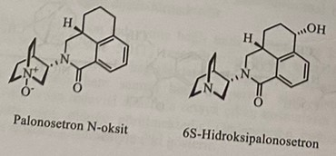
Vitamin B6 (Pyridoxine hydrochloride): 5-hydroxy-6-methyl-3,4-pyridinedimethanol hydrochloride. High doses of vitamin B6 are thought to be effective for vomiting in pregnancy, but no definitive studies have been conducted.
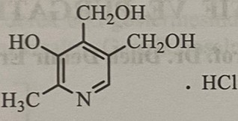
Laxatives and laxatives (agents)
Laxatives - drugs that soften the stool and thereby facilitate its removal during defecation. Laxatives are drugs that guarantee that the mucus will remain watery and facilitate its rapid involuntary release. Laxatives are also known as laxatives.
Laxative effect is an enhanced type of laxative action. Since some laxatives have a weak effect, they cannot have a laxative effect even when taken in large doses. Laxative substances have a laxative effect even when applied in small doses. According to these properties, the indicated preparations are studied in 2 groups: laxatives and laxative-slallatives. These preparations are taken orally and show their effect in the small intestine mainly in the large intestine. In very rare cases, laxatives and laxatives are used in the form of suppositories and enemas.
Liquid vaseline and mass-forming preparations usually facilitate defecation, having a physical effect on the chair. Laxative-laxative agents have a local effect on epithelial cells and nerves located in the mucous membrane of the large intestine, which is much thinner than their physical effect. It was believed that the mechanism of laxative and mainly laxative action is due to increased motility of the small and large intestines. But some studies have shown that high doses of stimulating laxatives, such as phenolphthalein, derivatives of anthraquinone and ricinoleate in castor oil, reduce the tone and peristalsis of the intestinal muscles. These drugs mainly reduce the tone of the circular muscles of the intestine and facilitate the movement of intestinal contents. But in toxic doses they can increase mobility.
Laxatives and laxatives are divided into 6 groups according to the mechanism of action and strength of action.
1) Softening laxatives
2) Mass forming laxatives
3) Osmotic laxatives and laxatives
4) Stimulating laxatives and laxatives
5) glycosides derived from anthraquinone
6) Other stimulant drugs
Mechanisms of influence
1) For mass formation
2) Strengthening intestinal peristalsis (Phenophthalein, anthraquinones)
3) Due to the accumulation of water in the intestines (the amount of water in the large intestine is 100-300 ml)
4) Inhibition of Na+/K+-ATPase of basolateral membrane of intestinal epithelial cells (phenophthalin, bisacodyl, danthrone, emodin)
5) When adenylate cyclase is activated, AMP, Na+ and Cl- (cholera toxin, ricinolenic acid, PG) are released in the intestinal tract
6) When the cytoplasmic membrane is damaged (Phenophtalin, bisacodyl, dihydrobilious acids, castor oil)
7) Increased synthesis of NO in the mucous membrane of the large intestine (ricinoleate, emodin, magnesium sulfate)
Astringent laxatives
Preparations of this group are divided into 2 groups, softening and moisturizing. Emollients are liquid vaseline, glycerin, olive oil, cottonseed oil and similar liquid vegetable oils that soften hair without causing diarrhea. Moisturizers are anionic surfactants. By reducing surface tension, they provide easy penetration of intestinal juice and fats into the large intestine and preserve its softness. Stimulating adenylate cyclase in epithelial cells, they can increase the accumulation of salts and water in the intestinal tract. This group includes the preparations sodium dioctylsulfosuccinate (Dokuzat sodium) and calcium dioctylsulfosuccinate (Dokuzat calcium). Derivatives of prostanic acid also act by stimulating the opening of chlorine channels in the intestines. They increase mucus secretion and reduce intestinal transit time. They reduce the time of emptying the stomach.
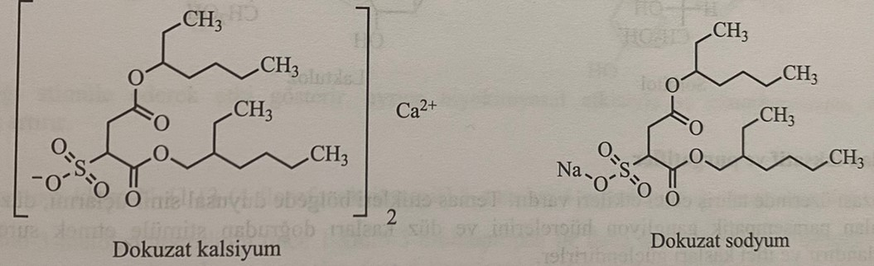
Bulking laxatives
This is a heterogeneous group of polysaccharides of plant origin, which are not digested or absorbed in the gastrointestinal tract. Physically and chemically, they are hydrophilic colloidal compounds, and when in contact with water, they swell, holding water, as a result of which their mass increases. After oral intake, they guarantee that the fat will remain soft in the gastrointestinal tract. This group includes methylcellulose, sodium carboxymethylcellulose, plantain seeds, agar, bran, etc.
Methylcellulose and sodium carboxymethylcellulose are semi-synthetic preparations obtained from cellulose. Plantain seeds act like the seeds of Plantago ovata, they are rich in hemicellulose. This substance captures bile acids and cholesterol in the liver. Agar Algae is a dried hydrophilic colloid obtained from various types of seaweed. The drug in the form of powder is mixed with water and taken. Bran is obtained from wheat flour and has a laxative effect.
Osmotic laxatives and laxatives
The stomach is salts and organic substances that are not absorbed or very little absorbed from the intestinal tract. The drug, which remains unabsorbed in the intestines, retains water and provides fat hydration.
Salt laxatives
1) Magnesium sulfate
2) magnesium citrate
3) Magnesium hydroxide
4) Sodium phosphate
Indigestible sugars
1) lactulose
Polyatomic alcohols
1) Glycerin
2) Sorbitol
3) Mannitol
4) Polyethylene glycol (macrogol)
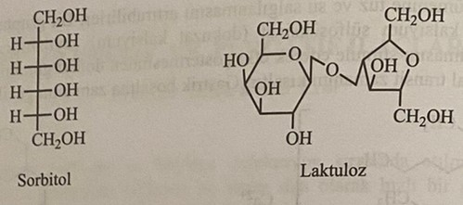
Stimulant laxatives
They have an irritating effect on the intestinal mucosa. In the area of their contact, they affect nerve endings, parasympathetic ganglion cells located between the muscles and the muscles directly.
Bisacodyl: 2-(4,4,-Diacetoxydiphenylmethyl)pyridine
Bisacodyl is formed by condensation of pyridine-2-carboxyaldehyde obtained by oxidation of 2-picoline with phenol in acidic medium.
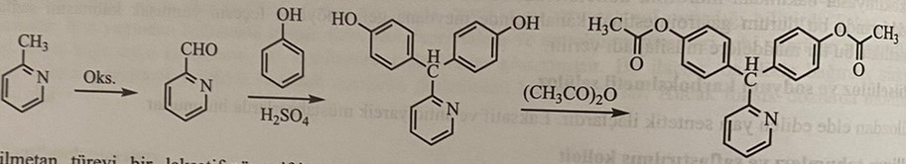
It is a laxative-purgative derivative of triarylmethane. When taken orally, it is largely absorbed from the small intestine. It is converted into glucuronate conjugate in the liver and enters the intestine with bile. Bisacodyl glucuronate is polar and is not absorbed from the intestines and moves towards the large intestine. This compound is hydrolyzed by microflora in the large intestine and exerts its effect. Bisacodyl undergoes rapid biotransformation in the liver, turning into bisacodyl diphenol.
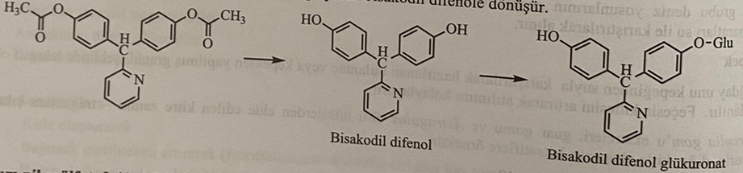
Sodium picosulfate : 2(4,4,-disulfoxydiphenylmethyl)pyridine disodium salt
It is formed by esterification of 2(4,4,-disulfoxydiphenylmethyl)pyridine with chlorosulfonic acid.
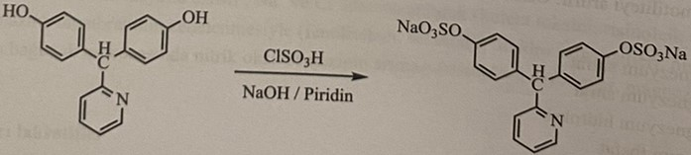
Phenophthalein: 3,3-Bis(4-hydroxyphenyl)-1-(3H)-isobenzofuranone
It is obtained by condensation of phenol with phthalic acid in front of Levis crystals.
It acts by stimulating the large intestine and prevents water absorption.
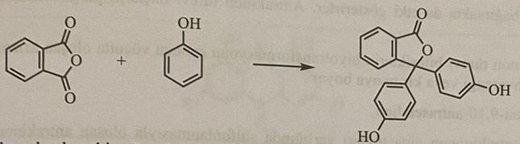
Cisaprite: 4-amino-5-chloro-N-{1-[3-(4-fluorophenoxy)propyl]-3-methoxy-4-piperidinyl}-2-methoxybenzamide
Cisaprite works by reacting the amide derivative of 4-amino-3-methoxypiperidine first with 1-chloro-3-bromopropane and then with 4-amino-2-methoxy-5-chlorobenzoyl chloride and 4-fluorophenol.
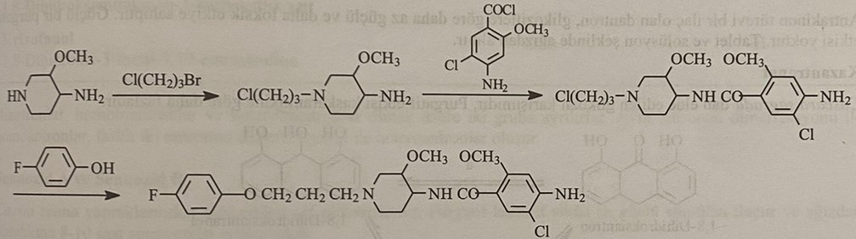
Cisaprite has a stimulating effect by increasing the secretion of acetylcholine in the intestinal tract. It is used in the treatment of stomach spasm and dyspepsia. The most common side effects are abdominal cramps, headache, dizziness, diuresis and ventricular arrhythmias.
Ricinol : [R-(Z)]-12-hydroxy-9-octadecenoic acid
It is the main substance obtained from castor oil. It is an 18-carbon ricinoleic acid triglyceride obtained from the seeds of the Ricinus communis plant. It is converted into glycerol and ricinoleic acid by the action of lipase enzyme in the small intestines. Ricinoleic acid is responsible for the purgative effect and makes up 80% of the total fat. This acid acts by irritating the intestinal mucosa. Increases intestinal peristalsis by increasing histamine secretion.
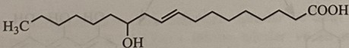
Derivative anthraquinone glycosides
Substances called sennoside A, sennoside B and senokot, contained in the leaves and fruits of the senna plant, the bark of the Rhamnus purshiana tree, a mixture of glycosides called canzanthranol obtained from it, the leaf of the aloe plant, the glycoside of aloin, the leaf of the rhubarb plant and danthrone, a synthetic derivative of anthraquinone , belong to this group.
The active part of the glycosides of this group of substances are the aglycone parts, which are derivatives of anthraquinone, and they are called emodin. Chemically shown aglycones of 1,8-dihydroxyanthrone and 1,8-dihydroanthroquinone, their dimerization products and glycosides. The hydrophilic and large glycoside molecule moves to the large intestine, practically not being absorbed in the small intestine and without significant hydrolysis. The glycoside is hydrolyzed by intestinal microflora, and the anthraquinone part becomes free. The free anthraquinone compound inhibits Na+,K+-ATPase in epithelial cells, prevents water absorption and has a laxative effect, irritating the intestinal mucosa. The free aglycone is partially absorbed in the large intestine. Passing through the liver, it undergoes changes in the bile and affects the small intestine. The laxative effect of anthraquinone derivatives is manifested 6-12 hours after ingestion.
As a result of biotransformation in the body of absorbed derivatives of anthraquinone compounds, chrysophanic acid is excreted from the kidneys and turns the urine brown or red.
Danthrone: 1,8-dihydroxy-9,10-anthracenedione
Anthraquinodisulfonic acid, formed during sulfonation of anthraquinone in the presence of mercury salts, is included in alkalization for the synthesis of danthrone. It is obtained as a result of the reaction of sodium salt with acid.
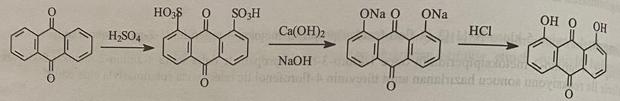
Compared to glycosides of dantron, which is a derivative of anthraquinone, it has a weaker effect and stronger toxicity. It does not have a strong laxative effect. It is used in the form of tablets and solution.
Casatranol
This is a mixture of glycosides obtained from cascara sagrada, its laxative effect is stronger than that of cascara.
They are divided into 3 groups: biantrons, homobiantrons and heterobiantrons. Homoanthrones are formed by dimerization of one and the same anthrone, and heteroanthrones are formed by dimerization of two different anthrones.
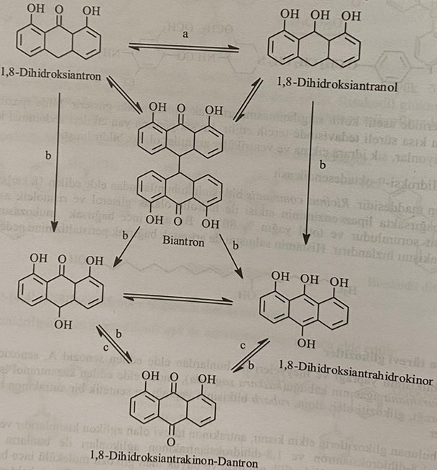
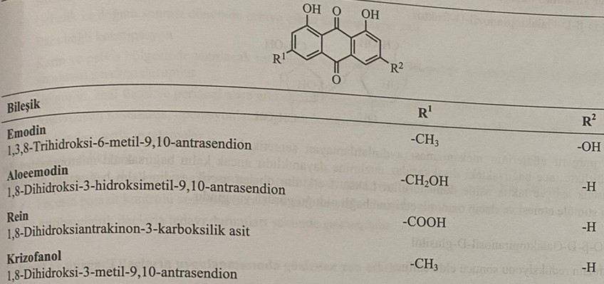
Sennazide A and Sennazide B
They are pure glycosides obtained from the leaves of Cassia senna. Stimulants have the strongest purgative-laxative effects, and their effect appears 8-10 hours after oral intake.
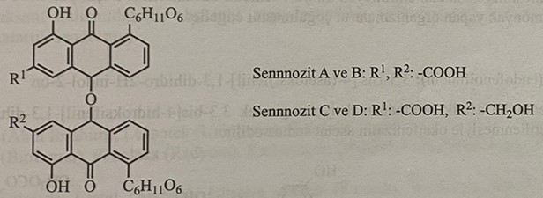
Glycosides are enzymatically hydrolyzed by bacteria in the intestines and become the active structure of 1,8-dihydroxyanthraquinones. Released anthraquinones inhibit Na+,K+-ATPase and prevent water absorption. Free anthraquinones that enter the large intestine are partially absorbed and enter the liver. Thus, they affect the small intestine. They are excreted by the kidneys and color the urine in brown or red color. This is connected with the formation of conjugated metabolites. The reaction of biotransformation of sennosite is presented below.
Other stimulants
Lactulose: 4-O-β-D-galactopranosyl-D-fructose
This is a synthetic disaccharide, the laxative and laxative effect of which has not been fully clarified. Being a classic stimulant, it has resistance to the enzyme disaccharidase in the small intestine. It is converted into vinegar and lactic acid by microorganisms in the large intestine. The irritating and osmotic action of acetic acid on the mucous membrane plays an important role in the occurrence of a laxative effect.
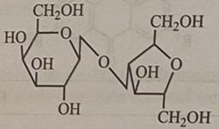
Lactitol : 4-O-β-D-Galactopranosyl-D-glucitol
Lactitol is formed as a result of the reduction of lactose.
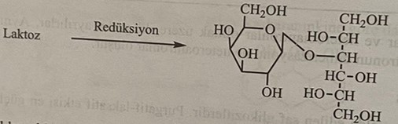
Like lactulose, it is a semi-synthetic saccharide that is not absorbed from the gastrointestinal tract. The low pH of the faecal product causes osmotic diarrhea and inhibits the growth of ammonia-producing microorganisms.
Oxyphenizatin Acetate (Endophenolphthalein) : 3,3-Bis-[4-(acetoxy)phenyl]-1,3-dihydro-2H-indol-2-one
Isatin reacts with two molecules of phenol in acidic medium to form 3,3-Bis-[4-(acetoxy)phenyl]-1,3-dihydro-2-indolinone. Acetylation of this compound yields oxyphenizatine acetate. 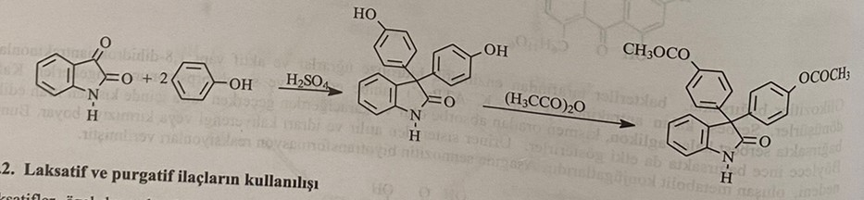
Use of laxatives and laxatives
Laxatives are drugs that must be used for a limited time, except in special cases. Long-term use leads to depression of the function of the large intestine and the rectal reflex. Since chronic constipation occurs due to inactivity, consumption of products with low fiber content and insufficient consumption of water, these factors should be eliminated first during treatment.
Laxatives are more often intended for one-time use, they are taken mainly at night before going to bed, and since their action begins after 6 hours, the patient's sleep is not disturbed by diarrhea. It should not be used in patients with appendicitis and abdominal infection or intestinal obstruction with symptoms such as abdominal pain, fever, nausea and vomiting.
Indications for the use of laxatives and laxatives
1) Chronic constipation
2) Constipation during pregnancy and after childbirth
3) Constipation caused by drugs
4) X-ray methods performed in the abdomen (rectoscopy, colonoscopy and surgical interventions)
5) Cases of painful defecation, such as hemorrhoids, anal fissure and perianal abscess.
6) Before surgery in patients with aneurysm
7) Before radiation diagnosis
8) Drug and food poisoning
9) Get a fresh stool sample for parasitological diagnostics.
10) With complex treatment with anthelmintic drugs
Expected side effects of laxatives and laxatives
1) Dehydration, hypokalemia, hypoaldosteronism caused by long-term use of laxatives
2) Hypoalbuminemia caused by enteropathy in the large intestine
3) Deficiency of vitamins, osteomalacia
4) Intestinal bleeding can be observed with acute appendicitis, typhoid fever, intestinal trauma, necrosis and ulcers.
5) Risk of premature birth towards the end of pregnancy
6) Risk of diarrhea in a child during lactation
7) Constipation and irreversible damage to the colon
Antidiarrheal drugs
Diarrhea is a condition characterized by liquefaction of fecal masses and increased intensity of defecation. Acute diarrhea causes abdominal pain, loss of water and electrolytes, which leads to dehydration, hypokalemia and metabolic acidosis. Loss of water and electrolytes in chronic diarrhea causes hypovitaminosis and anemia.
There are many factors that cause diarrhea. It is caused by foreign pathogenic organisms, toxins, infections, functions of the stomach, pancreas, biliary tract of the intestinal flora.
Antidiarrheal drugs are divided into two groups: specific and non-specific.
Specific antidiarrheal drugs are used in the treatment of diarrhea caused by pathogenic microorganisms, toxic substances found in food products, medicines and other causes of diarrhea. It is known that human rotavirus is the cause of microbial diarrhea, and no antiviral drug has been found against this virus. For this reason, liquids for oral rehydration are used in microbiological diarrhea.
Nonspecific antidiarrheal drugs are used to reduce or eliminate the symptoms of diarrhea. These drugs are divided into 3 groups according to the mechanism of action.
1) Opiates and other opioids
2) Anticholinergic drugs
3) Adsorbents and mass formers
4) Salts for oral rehydration
5) Preparations used for special treatment
a) Antibacterial treatment - Shigella, Salmonella, Escherichia coli
b) Antiprotozoic treatment-E. Histolytica, giardia
Pancreatic enzymes
Acetylsalicylic acid-gluten enteropathy, food allergy
Opiates and other opioids
They are used to cause a spasm of the circular muscles of the large intestine, suppress peristalsis and reduce increased fluid secretion. This is a group of antidiarrheal drugs that have the fastest and strongest action. They have side effects such as dry mouth, nausea, vomiting and headache.
Codeine: (methylmorphine) (5α,6α)-7,8-didehydro-4,5-epoxy-3-methoxy-17-methylmorphinan-6-ol
Codeine is obtained by methylating morphine in an alkaline environment.
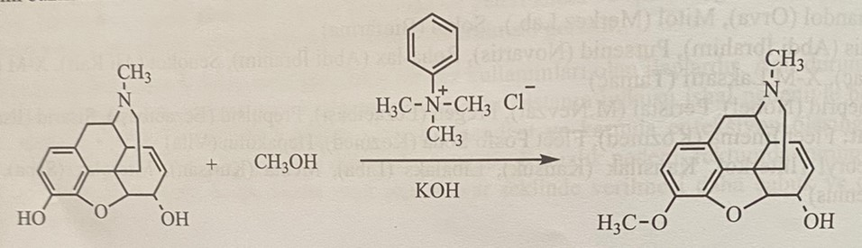
It has been known for many years that opium tincture reduces intestinal motility and causes constipation. The motility-inhibiting properties of opiate analgesics were obtained by combining the action groups of the synthetic opiate analgesic methadone and pethidine.
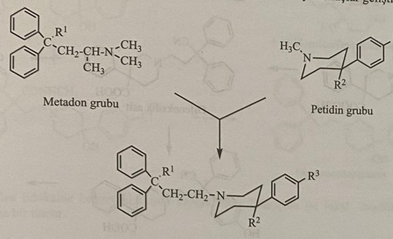
The first compound obtained is diphenoxylate. New preparations were synthesized by changing R1 and R2 groups of this compound.
Diphenoxin: 1-(3-Cyano-3,3-diphenylpropyl)-4-phenylpiperidine-4-carboxylic acid
Diphenoxylate: Ethyl 1-(3-Cyano-3,3-diphenylpropyl)-4-phenyl-4-piperidinecarboxylate
It is an antidiarrheal substance derived from meperidine. It is used in the form of tablets or solution together with atropine. Diphenoxylate has more side effects than difenoxin.
Diphenoxin and diphenoxylate are obtained from the condensation of 4-bromo-2,2-diphenylbutyronitrile with 4-phenylpiperidine, obtained as a result of the reaction of diphenylacetonitrile with 1,2-dibromoethane.
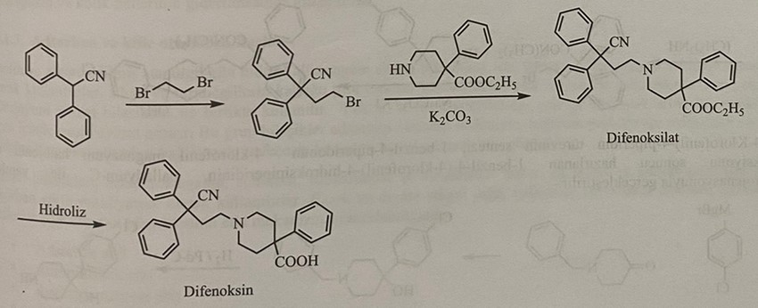
The synthesis of the 4-phenylpiperidine derivative used in the reaction is carried out by first reacting phenylacetonitrile with N,N-bis(2-chloroethyl)amine and then by hydrolysis of the nitrile group.
Diphenoxylate is metabolized in the liver, but most of it is excreted unchanged. The most important biotransformation reaction is ester hydrolysis. Diphenolic acid is more active than diphenoxylate. Another metabolite is hydroxyphenoxylic acid. Both metabolites are excreted from the body in the form of glucuronate.
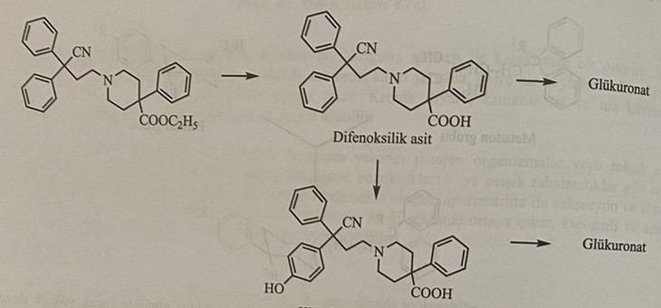
Loperamide: 4-(4-chlorophenyl)-4-hydroxy-N,N-dimethyl-α,α-diphenyl-1-piperidine butyramide
4-bromo-2,2-diphenylbutanoic acid is obtained from the reaction of the intermediate product obtained as a result of the reduction of ethyl diphenylacetate with oxirane with bromic acid. Loperamide is obtained by reacting 4-bromo-2,2-diphenylbutyramide with 4-(4-chlorophenyl)-4-piperidine, formed by the reaction of this compound first with thionyl chloride and then with dimethylamine.
Synthesis of 4-(4-chlorophenyl)-4-piperidine derivative Hydrogenation of 1-benzyl-4-(4-chlorophenyl)-4-hydroxypiperidine with palladium-C, resulting from the reaction of 1-benzyl-4-piperidone with 4-chlorophenyl magnesium halide is carried out with
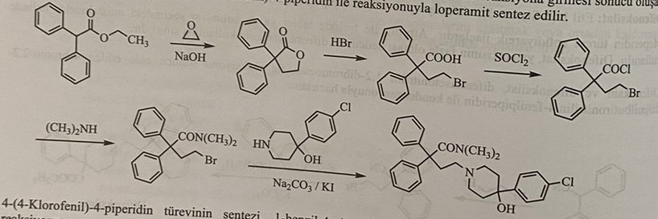
Diphenoxylate is a new antidiarrheic drug derived from meperidine. In addition to the specific antidiarrheal effect found in opiate drugs, it also has a non-specific effect. Its specific effect is to prevent the loss of water and electrolytes in the intestines. Its non-specific effect is that intestinal epithelial cells block calcium channels.
Loperamide is metabolized in the liver. 1.4% is excreted unchanged in urine, 15-23% in feces, and 58% in bile. It undergoes demethylation and N-dealkylation reactions. As a result, 4-(4-chlorophenyl)-4-hydroxy piperidine metabolites were found.
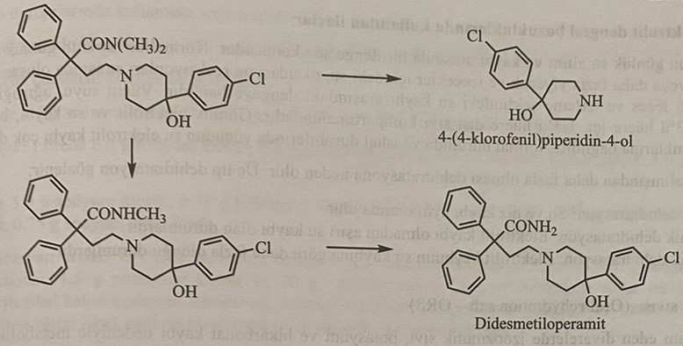
Lidamide, which has a chemical structure similar to lidocaine, was discovered in recent years and is a locally effective antidiarrheal drug.
Lidamidine: N-(2,6-dimethylphenyl)-N,-[imino(methylamino)methyl]urea.
Lidamidine is obtained by the reaction of 2,6-dimethylphenylisocyanate with N-methylguanidine.
Parasympatholytic drugs
Atropine and similar substances. They are used to reduce intestinal tone in the treatment of diarrhea.
Adsorbent and mass forming preparations
Hydrated aluminum silicate compounds such as kaolin and activated attapulgite are used in the treatment of diarrhea in the form of powders, tablets and suspensions. It is used together with pectin obtained from plants. Pectin reduces the nitrogen loss in the feces by reducing the synthesis of ammonia produced by bacteria.
Bismuth compounds, bismuth subgallate, subnitrate, subcarbonate and subsalicylate salts are used as adsorbents in the form of tablets and suspensions. When we look at the mechanism of action of bismuth compounds:
1) Adsorbent effect
2) Antimicrobial effect
3) Anti-inflammatory effect
4) Antisecretory effect
It forms a mass by holding water in the intestinal tract.
Substances that restore water and electrolyte balance
There is a balance between the daily water intake and loss of the human body. A normal person's daily intake of water is 1500-2000 ml. Water makes up 58% of the body's weight. The body's water loss is very variable in normal and diarrheal conditions. Dehydration is when water loss exceeds water intake. There are three types of dehydration:
1) Isotonic dehydration: Water and salt loss occur simultaneously.
2) Hypertonic dehydration: Extreme water loss occurs in the absence of electrolyte loss.
3) Hypotonic dehydration: Electrolyte loss is greater than water loss.
Rehydration fluid
In long-term diarrhea, some metabolic disturbances occur with the loss of potassium, bicarbonate and iso-osmotic fluid. This condition is called dehydration. During dehydration, hypokalemia and metabolic disturbances are observed.
For oral rehydration, isoosmotic sodium and glucose, potassium, and bicarbonate ions-binding solutions are used. The absorption of sodium ions increases due to the glucose absorbed by the rehydration fluid. Water absorption is carried out by three variable mechanisms.
1) Passive diffusion: Sodium is absorbed by passive diffusion from both the small and large intestines. Due to its electrochemical charge, sodium ions pass through specific ion channels into the cell by this mechanism.
2) Active sodium pump: Occurs with ion exchange in neutral sodium chloride absorption. These are Cl/HCO3 and Na/H ion exchange.
3) Glucose-dependent sodium channels: Sodium can be transported in combination with various compounds. These include glucose, amino acids, water-soluble vitamins and organic acids. The most ideal are sodium-glucose connections. The glucose used in the rehydration fluid is given not to give the patient strength, but to facilitate the absorption of sodium from the small intestine. Although the first two mechanisms are realized in the large intestine, the third mechanism is realized in the small intestine. Treatment with oral rehydration fluids is based on 3 mechanisms.
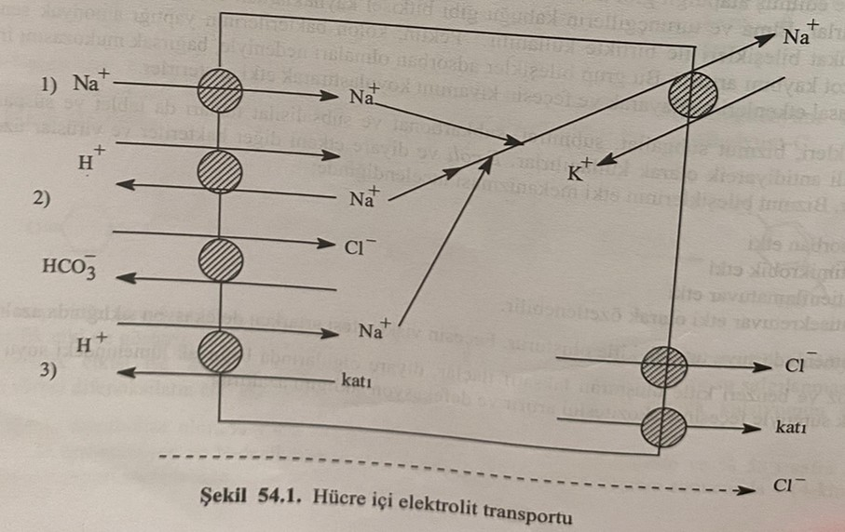
Fluids used in case of dehydration:
1) 0.9% sodium chloride solution: contains 154 mEq/l sodium and 154 mEq/l chlorine.
2) 5% glucose solution
3) Ringer's solution: It contains 8.6 g of sodium chloride, 0.3 g of potassium chloride and 0.33 g of calcium chloride per liter.
4) Lactated Ringer's solution: 6 g of sodium chloride, 0.3 g of potassium chloride, 0.2 g of calcium chloride and 3.1 g of sodium lactate per liter.
5) Isolite: 5 g of sodium chloride, 0.75 g of potassium chloride, 0.33 g of calcium chloride, 6.4 g of sodium acetate, 0.75 g of sodium citrate per liter.
6) Oral rehydration liquid: It is a solution recommended by UNICEF for babies. It contains 3.5 g of sodium chloride, 5 g of sodium bicarbonate, 1.5 g of potassium chloride and 20 g of glucose per liter.
7) Bicarbonate oral rehydration liquid: It is prepared by mixing one liter of boiled and cooled water, 3.5 g of sodium chloride, 2.5 g of sodium bicarbonate, 1.5 g of potassium chloride and 20 g of glucose. 50 g of rice flour is added instead of bicarbonate in mixtures that make rice flour.
Prebiotics and Probiotics
All diseases start from the gut (Hippocrates). The meaning of the word probiotic comes from the Greek word for life. According to the WHO, probiotics are microorganisms that are very beneficial to human health when administered in certain doses. Years ago, Elie Matchinoff put forward the idea of using harmless microorganisms found in the human body in the treatment of diseases. Most of the microorganisms used as probiotics belong to the group of lactic acid bacteria.
It has been found that some bacteria thought to be the cause of disease are actually gut friendly bacteria. These bacteria are involved in the breakdown of carbohydrates, proteins and fats in the digestive system and at the same time in the synthesis of some vitamins. These good bacteria in the gut keep the digestive system in balance.
Factors such as infections, used antibiotics, alcohol, stress, and poor nutrition lead to disruption of the intestinal microflora. This imbalance causes diarrhea, abdominal bloating, indigestion, constipation and lowered immunity. Probiotics both restore gastrointestinal balance and boost the immune system. Prebiotics are the main food of intestinal microflora. That is, it feeds the bacteria in the microflora. If the patient takes probiotic and prebiotic together, it is called symbiotic. Probiotics are actually living bacteria. For this reason, they cannot stay alive at room temperature. 80-90% of these bacteria are destroyed by stomach acidity and bile. Therefore, these preparations are prepared with special technology. This technology is dual coated technology. The primary layer protects these bacteria from external factors such as light, heat, moisture, and the second layer protects them from stomach and bile acids.
100 trillion (1.5 kg) of beneficial gut bacteria (probiotics) live in our intestines. This is 10 times more than the number of cells in the human body.
Some microorganisms used as probiotics
1) Lactobacillus GG
2) Lactobacillus reuteri
3) Lactobacillus acidophilus
4) Lactobacillus casei
5) Lactobacillus rhamnosus
6) Lactobacillus bulgaricus
7) Lactobacillus fermentum
8) Saccharomyces boulardii
9) Streptococcus thermophiles
10) Eschrichia nissle 1917
11) Bifidiobacterium bifidum
12) Bacillus subtilis
Functions of probiotics
1) To strengthen the immune system
2) Facilitating the digestion of food
3) Participate in vitamin synthesis
4) Protecting the intestinal wall from harmful substances
5) To prevent chronic infectious diseases
6) Prevention of cancer
7) Slow down aging
8) Alleviate depression
9) Prevent and treat diarrhea
10) To prevent inflammation of the urinary tract
11) Treatment of constipation
12) Reduce the formation of kidney stones
Probiotics participate in the synthesis of K2, B1, B2, B3, biotin, B12, folic acid and pantothenic acid.
Prebiotics
In the conducted studies, it was determined that carbohydrates, known as oligosaccharides, play an important role in the development and reproduction of probiotics. Oligosaccharides belong to prebiotics. In short, prebiotics are substances that cannot be digested but are fermented in the intestines and allow bacteria to multiply. Prebiotics include inulin galacto, fructo, oligosaccharides.

